Saint John’s Academy, Allahabad
ENTRANCE TEST SYLLABUS 2016-17

FOR CLASS NURSERY

# The interview for the student shall be conducted in English only, therefore knowledge
of spoken English is a must.
# The candidate should understand and state simple, day to day requests in English.
E.g. a) May I go to drink water.
b) Please take out your English Reader.
c) My ear is paining.
d) I have forgotten to bring my tiffin box etc.
Criteria for entrance:

The entrance to this level is based upon :-

- An interaction session with the child. This is an informal interaction of the child with the teacher and the following are credited :-

(1) The Child’s ability to –

# Speak clearly and coherently in English and Hindi or EITHER of the two languages. (Children who can speak only regional or vernacular language shall not be considered for admission for reasons of their own safety).

# Distinguish, identify and name common colours, objects, flowers, fruits, vegetables, vehicles and common farm animals.

# Clearly state his / her own name, the names of both parents and brothers and sisters, if any.

# Answer simple questions concerning daily activities.

# Recite a couple of rhymes in English and in Hindi.

- The child’s alertness and creativity.

- Recognize and write English alphabets A to Z.
and write numbers 1 to 10.
Recognize – Hindi alphabets from v ls v%
Recognize shapes like square, triangle, circle etc and relate
objects to a particular shape.

- An interview of both mother and father compulsory.

The child should know :
One English rhyme.
One Hindi rhyme. [Continued …]
[Page 2]
Fill in the blanks
eg: B C D E

Circle the correct letter
eg: R P S
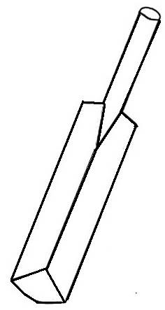
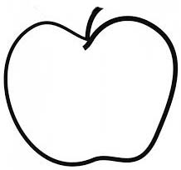
The first letter is
eg:
A
B

fp= dks ns[kdj igyk v{kj fy[kks µ
eg:
vk

Count and draw
5 = O O O O O

Fill in the missing numbers
1 2 3 4 5

Count and circle the correct number
O O O O 6 3 4

Count and write
= 3

Recognition of fruits : Apple, mango, orange, papaya, grapes, watermelon, pineapple, cherries.
Recognition of vegetables : Onion, potato, tomato, radish, spinach, cabbage, capsicum.
Recognition of flowers : Rose, lotus, sunflower, marigold, lily, daisy.
Recognition of colours : Red, blue, green, yellow, black, white.
Parts of the body : Hands, feet, face, neck, eyes, ears, nose.
Names of common vehicles : Bus, train, motor cycle, auto-rickshaw, scooter, car, truck, bicycle.

*-*-*-*-*-*-*-*-*-*-*-*-*-*-*-*-*-*-*-*-*-*-*-*-*-*-*-*-*-*-*-*-*-*-*-*-*-*-*-*-*-*-*-*-

