SAINT JOHN’S ACADEMY, ALLAHABAD

CLASS PREP SEC……. WINTER VACATION HOMEWORK 2014-15

NAME : _ _ _ _ _ _ _ __ _ _ _ _ _ _ _ _ __ _ _ _ _ _ _ _ _ __ _ ADM CODE…..

1) Write the number names.

|  |  |
| --- | --- |
| 109 |  |

|  |  |
| --- | --- |
| 150 |  |

|  |  |
| --- | --- |
| 93 |  |

|  |  |
| --- | --- |
| 86 |  |

|  |  |
| --- | --- |
| 110 |  |

|  |  |
| --- | --- |
| 147 |  |

**2) Write the numbers starting with the smallest first (ascending order).**

|  |  |  |  |  |  |  |  |
| --- | --- | --- | --- | --- | --- | --- | --- |
| a) | 42 |  | 24 |  | 54 |  | 95 |
|  |  |  |  |  |  |  |  |

|  |  |  |  |  |  |  |  |
| --- | --- | --- | --- | --- | --- | --- | --- |
| b) | 21 |  | 13 |  | 31 |  | 12 |
|  |  |  |  |  |  |  |  |

|  |  |  |  |  |  |  |  |
| --- | --- | --- | --- | --- | --- | --- | --- |
| c) | 56 |  | 73 |  | 92 |  | 68 |
|  |  |  |  |  |  |  |  |

**3) Write the numbers starting with the biggest first (descending order).**

|  |  |  |  |  |  |  |  |
| --- | --- | --- | --- | --- | --- | --- | --- |
| a) | 38 |  | 42 |  | 36 |  | 40 |
|  |  |  |  |  |  |  |  |

|  |  |  |  |  |  |  |  |
| --- | --- | --- | --- | --- | --- | --- | --- |
| b) | 50 |  | 55 |  | 65 |  | 73 |
|  |  |  |  |  |  |  |  |

|  |  |  |  |  |  |  |  |
| --- | --- | --- | --- | --- | --- | --- | --- |
| c) | 54 |  | 81 |  | 63 |  | 72 |
|  |  |  |  |  |  |  |  |

p.t.o

**4) Show the given time :**

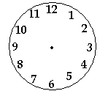

7:00 2:00 9:00

5**) Write the ordinal numbers for encircled object :**

1)

2)

3)

4)

5)

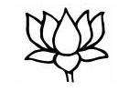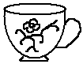

**7) Write in expanded form :**

|  |  |  |  |  |  |  |  |  |  |  |  |  |  |  |  |  |  |  |  |
| --- | --- | --- | --- | --- | --- | --- | --- | --- | --- | --- | --- | --- | --- | --- | --- | --- | --- | --- | --- |
|  | **T** | **O** |  | **T** | **O** |  | **T** | **O** |  | **T** | **O** | |  | **T** | **O** | |  | **T** | **O** |
|  | 2 | 7 |  | 4 | 9 |  | 1 | 8 |  | 6 | 8 | |  | 1 | 7 | |  | 5 | 1 |
| **+** | 1 | 2 | **–** | 2 | 1 | **+** | 8 | 1 | **–** | 3 | 2 | | **+** | 0 | 2 | | **+** | 0 | 4 |
|  |  |  |  |  |  |  |  |  |  |  | |  |  |  | |  |  |  |  |

**6) Solve the following:**

|  |  |  |  |  |  |  |  |  |  |  |  |  |  |  |  |  |  |
| --- | --- | --- | --- | --- | --- | --- | --- | --- | --- | --- | --- | --- | --- | --- | --- | --- | --- |
|  | **T** | **O** |  | **T** | **O** |  | **T** | **O** |  | **T** | **O** |  | **T** | **O** |  | **T** | **O** |
|  | 5 | 6 |  | 2 | 7 |  | 4 | 8 |  | 2 | 4 |  | 1 | 2 |  | 5 | 9 |
| **–** | 1 | 6 | **+** | 1 | 2 | **+** | 3 | 1 | **+** | 6 | 2 | **+** | 7 | 8 | **–** | 3 | 3 |
|  |  |  |  |  |  |  |  |  |  |  |  |  |  |  |  |  |  |

69 = _ _ _ _ _ _ _ __ _ 91 = _ _ _ _ _ _ _ __ _

73 = _ _ _ _ _ _ _ __ _ 87 = _ _ _ _ _ _ _ __ _

42 = _ _ _ _ _ _ _ __ _ 35 = _ _ _ _ _ _ _ __ _

**8) Identify the shapes and name them:**

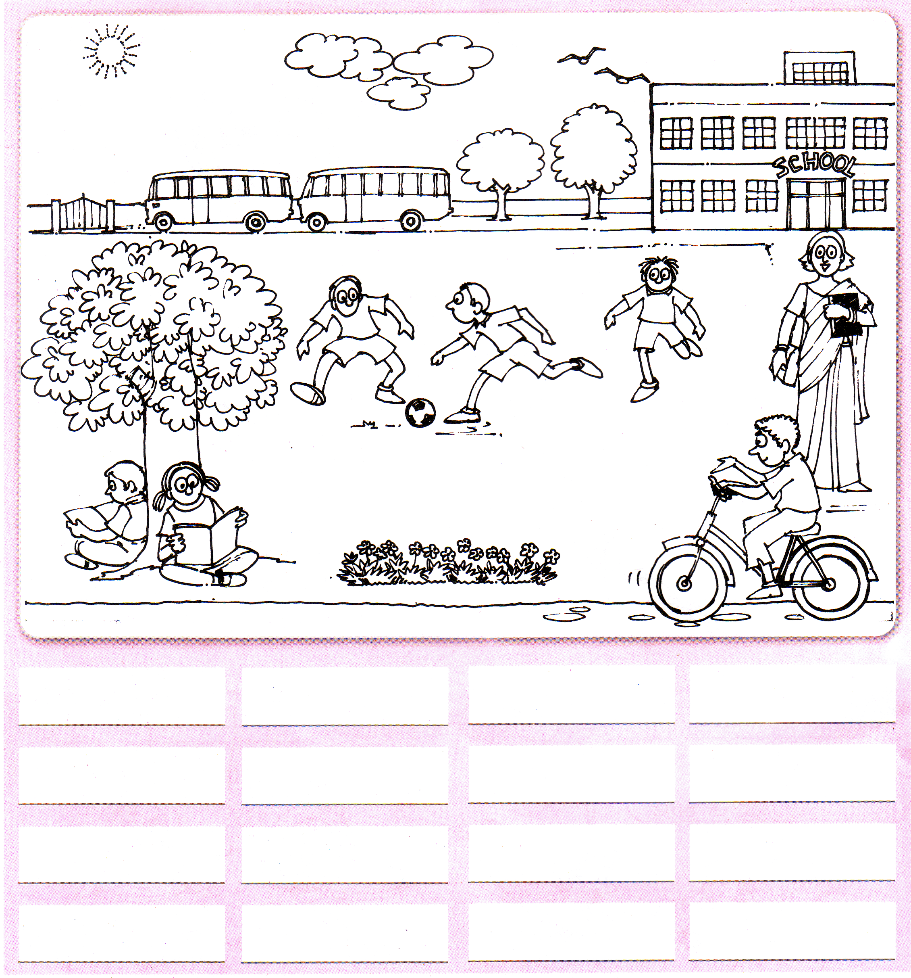

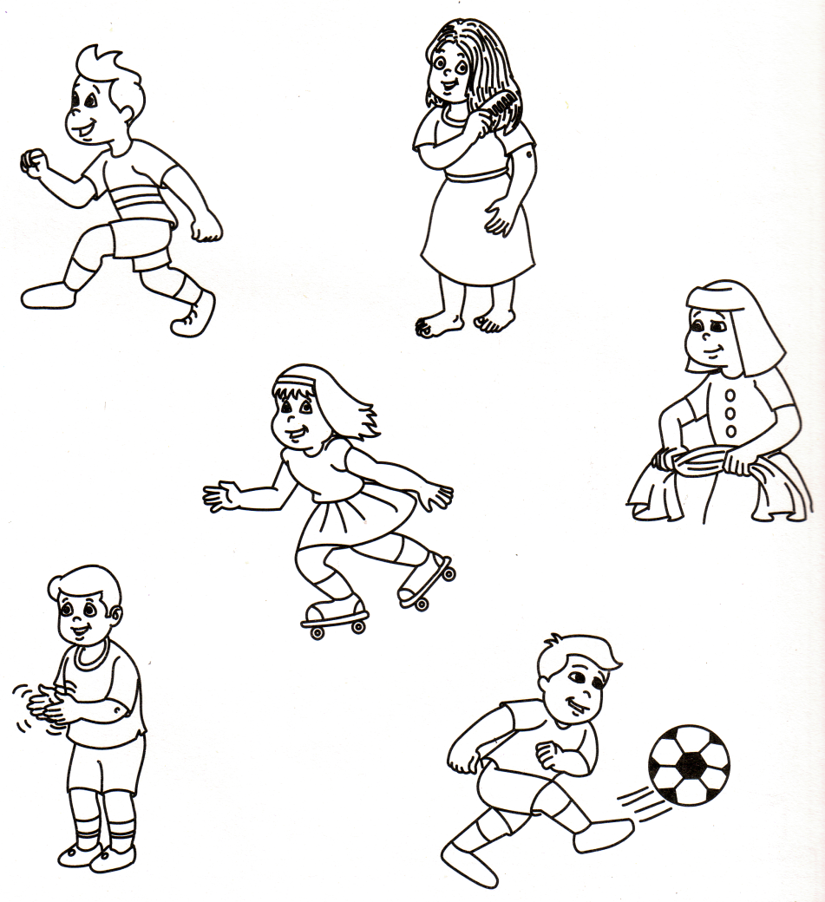

*-*-

**E.V.S**

**1) Name the seasons in which you wear these clothes :**

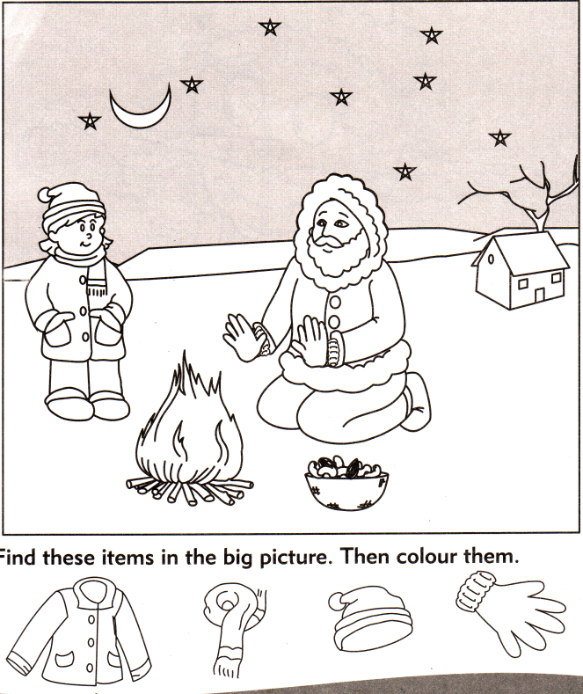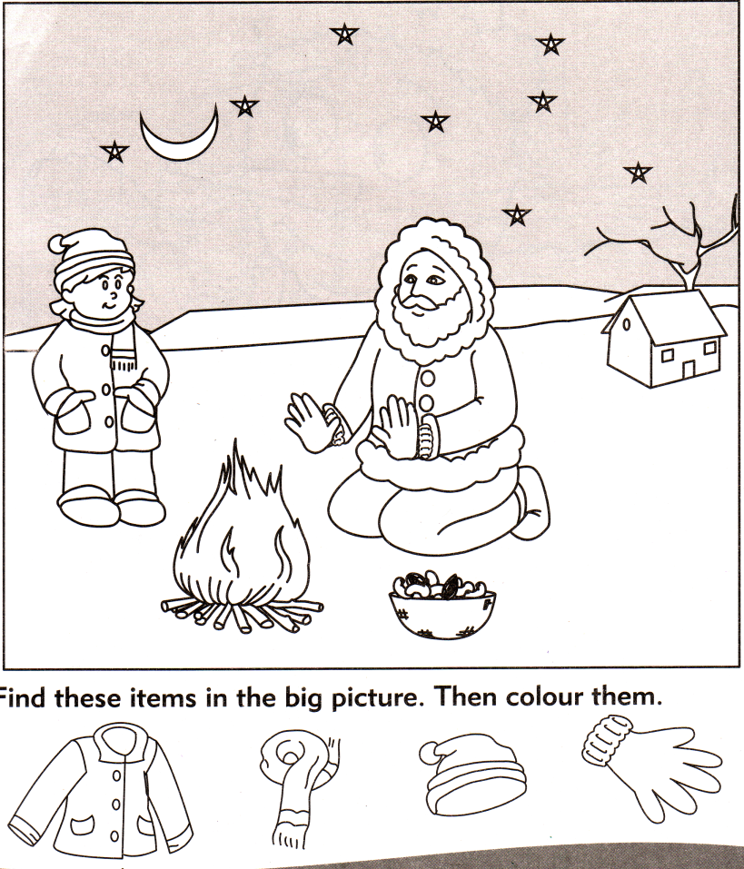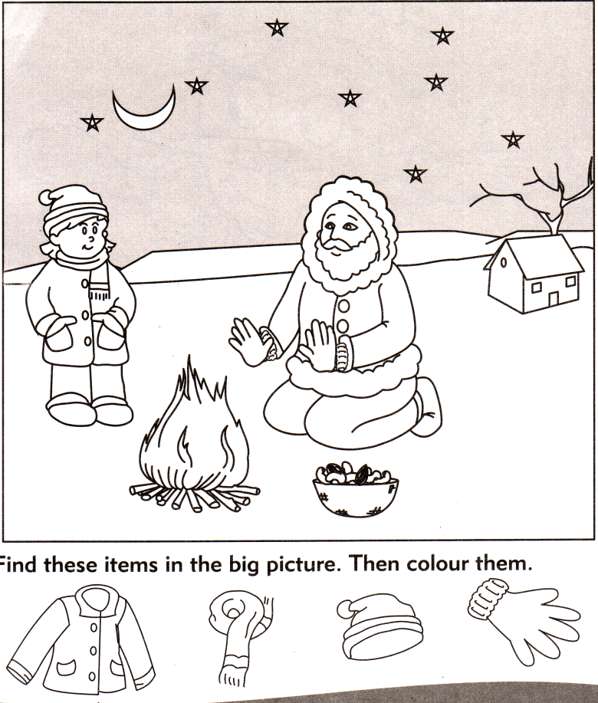

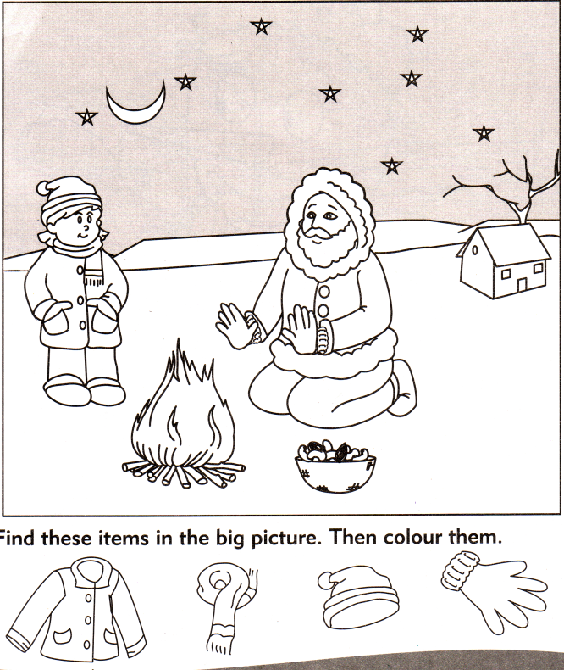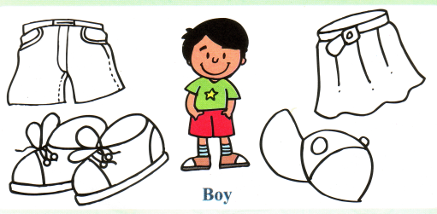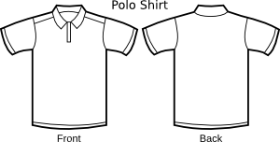

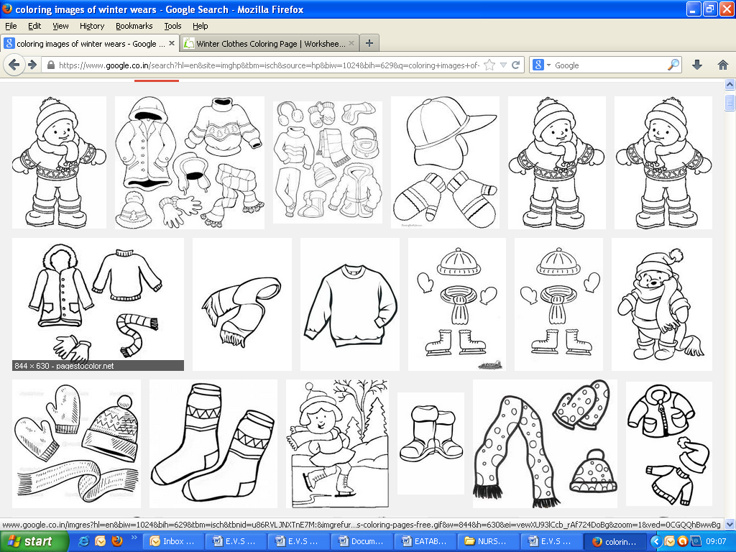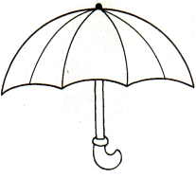

**2) Complete the names of the means of communication :**

|  |  |  |
| --- | --- | --- |
|  |  |  |
| T ___ L ___ P H ___ N E |  | L ___ T T ___ R |

|  |  |  |
| --- | --- | --- |
|  |  |  |
| T ___ L ___ V I S I ___ N |  | R ___ D ___ O |

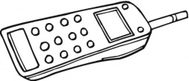

|  |  |  |
| --- | --- | --- |
|  |  |  |
| N ___ W S ___ A P ___ R |  | M ___ B ___ L ___ |

**3) Colour the traffic signal :**

STOP

SLOW

GO

p.t.o

[PAGE 2]

**4) Name the pictures you see in a park.**

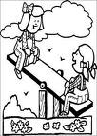

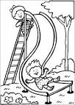

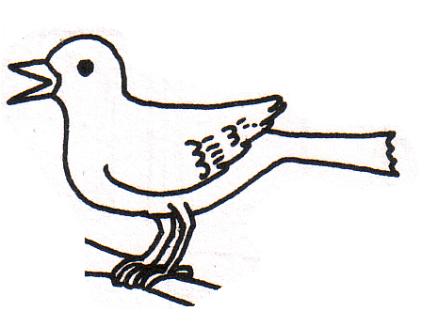

**5) Write for the activities done during the day, for night and for both :**

1. We go to school.
2. We pray.
3. We have our dinner.
4. We brush our teeth.
5. We have lunch.
6. We go to sleep.
7. We eat our breakfast.

**6) Draw and name any two things with which you should not play with as they will harm you.**

Cont…

**7) Look at the pictures and name the different kinds of places on our earth:**

|  |  |  |
| --- | --- | --- |
|  |  |  |
|  |  |  |
|  |  |  |
|  |  |  |

**8) Draw and name any two things which help you to keep your body clean.**

**9) Name the places of worship :**

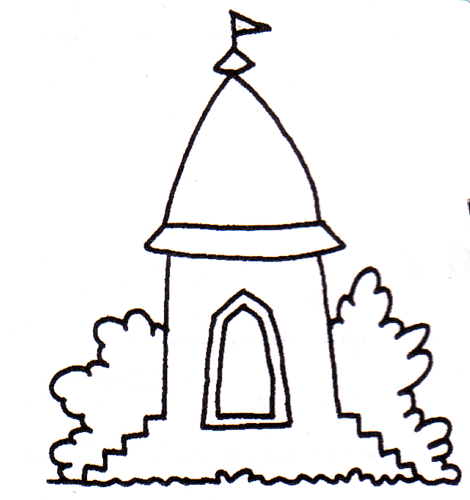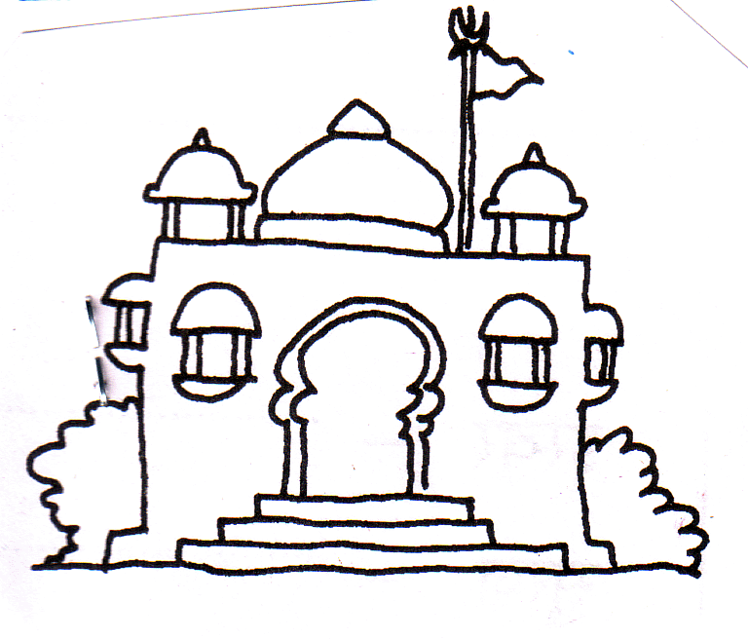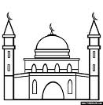

1. Sikhs go to a ________________ .
2. Hindus go to a ________________ .
3. Muslims go to a ________________ .
4. Christians go to a ________________

**10) Fill in the blanks with ‘living’ or ‘non-living’ :**

1. A tree is a _____________ thing.
2. A kite is a _____________ thing.
3. A dog is a _____________ thing.
4. The moon is a _____________ thing.

*--*--END--*--*

**[ENGLISH]**

**1) Circle the opposite :**

1. in go out on
2. boy up man girl
3. hot cold dry fat
4. dry thin tall wet

**2) Circle the name of the pictures and colour the picture :**

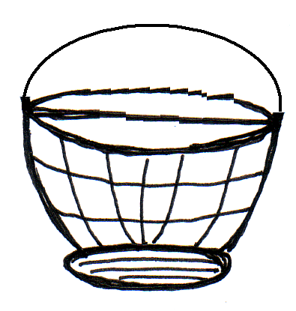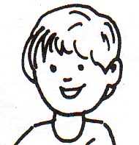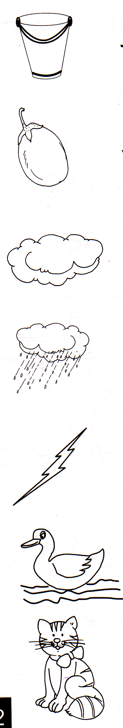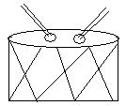

man

boat

bucket

basket

flower

fruits

boy

girl

tree

drum

plum

pot

**3) Complete the name of the things :**

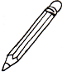

C ___ ___ t

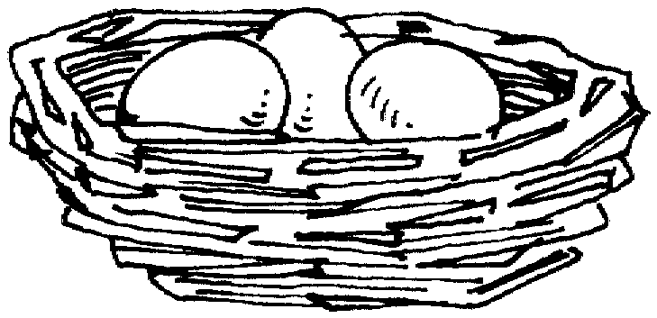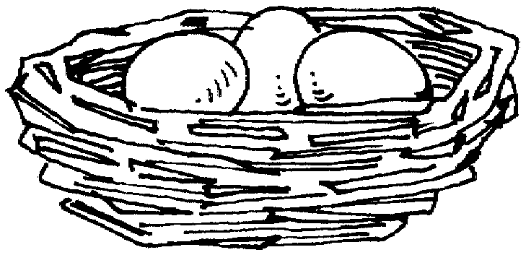

P ___ n c ___ l

G ___ ___ p ___ s

N ___ ___ t

**4) Write ‘A’, ‘An’ or ‘The’ :**

_ _ _ _ apple _ _ _ _ book

_ __ __ sun __ _ _ egg

_ _ __ _ tree _ _ __ _ moon

**P.T.O**

**[PAGE 2]**

**5) Write the rhyming words :**

|  |  |  |  |  |  |
| --- | --- | --- | --- | --- | --- |
|  | cry |  |  |  |  |

|  |  |  |  |  |  |
| --- | --- | --- | --- | --- | --- |
|  | far |  |  |  |  |

|  |  |  |  |  |  |
| --- | --- | --- | --- | --- | --- |
|  | boil |  |  |  |  |

|  |  |  |  |  |  |
| --- | --- | --- | --- | --- | --- |
|  | land |  |  |  |  |

|  |  |  |  |  |  |
| --- | --- | --- | --- | --- | --- |
| 5) | cup |  |  |  |  |

**6) Colour the picture and answer the following questions :**

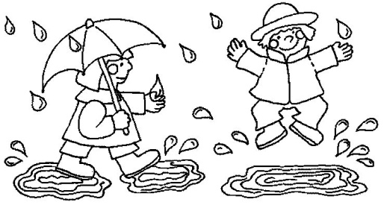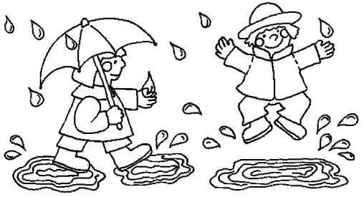

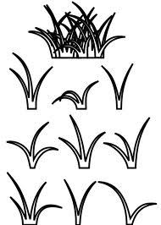

Q.1) Which season is this ?

Ans: This is _ _ _ _ _ _ _ __ _ _ _ _ _ season.

Q.2) What is the girl carrying ?

Ans: The girl is carrying an _ _ _ _ __ _ _ _ _ _ _ _ _ __ _ .

Q.3) What can you see everywhere ?

Ans: I can see _ _ _ _ _ _ _ _ __ _ everywhere.

Q.4) What can you see in the sky ?

Ans: I can see a __ _ _ _ _ _ _ _ _ __ _ _ _ and the __ _ _ _ _ _ _ __ _ in the sky.

Cont…..

[PAGE 3]

**7) Colour the names of the days of the week :**

Saturday

September

Thursday

January

Tuesday

October

Sunday

**8) Write the months of the year in order :**

1) J_ _ _ _ _ _ _ __ _ _ _ _ _ __ _ 2) F _ _ _ _ _ _ _ __ _ _ _ _ _ __ _

2) M_ _ _ _ _ _ _ __ _ _ _ _ _ __ _ 4) A _ _ _ _ _ _ _ __ _ _ _ _ _ __ _

5) M_ _ _ _ _ _ _ __ _ _ _ _ _ __ _ 6) J _ _ _ _ _ _ _ __ _ _ _ _ _ __ _

7) J_ _ _ _ _ _ _ __ _ _ _ _ _ __ _ 8) A _ _ _ _ _ _ _ __ _ _ _ _ _ __ _

9) S_ _ _ _ _ _ _ __ _ _ _ _ _ __ _ 10) O _ _ _ _ _ _ _ __ _ _ _ _ _ __ _

11) N_ _ _ _ _ _ _ __ _ _ _ _ _ __ _ 12) D _ _ _ _ _ _ _ __ _ _ _ _ _ __ _

*-*-END-*-*-*