SAINT JOHN’S ACADEMY
WINTER HOLIDAY HOMEWORK (2014 - 2015)
CLASS VIII
NOTE:- These assignments are to be done on separate answer sheets and submitted to the subject teachers on the first day when the school reopens.

ENGLISH LANGUAGE
Q1. Imagine you see someone throwing plastic bags/ wrappers in the park. You think the person should pick them up and throw them in the dustbin. How would you tell the person if the person who has littered is
- Your best friend
- A senior citizen
- Your family member [ father or mother ]
- Your brother/ sister.
OR
Students have a tendency of using unfair means during examination. Write an article to be published in your school magazine to warn students regarding the consequences of this bad habit. [ 150 words ]
Hints:
- Bad Means
- Lack of self confidence
- Against faith
- No ethics and values
- Makes one parasite to cheating
- Makes one fraudulent
- Spoils the students profile
- Ruins the career
Q2. Make a project file on any one of the given topics:
- Fashion
- Environment
The project must be presented very neatly with colourful borders, picture, photographs and drawings.
It should be written in the following way:
- Introduction
- The changing ideas about the topic
- Description of the various things and issues related to your topic.
- A report of your analysis of what people feel about your topic on the basis of your interview of TWO people from different age groups (Attach a copy of your questionnaire along with this)
OR
Write the review of any one English movie that you have seen and enjoyed. Your
work should be neat and clean. You can add pictures, photographs or drawings if you like. Each review should carry the following details about the film.
- Its title
- The name of the director
- The names of the writers of the story and the dialogue
- What kind of a film it is whether it is a cartoon film, an adventure story/ a comedy, a tragedy, a historic drama.
- The best thing about the film and the thing about it that you did not like.
For example:
- Harry Potter and the Prisoner of Azkaban
- The Karate Kid
- Charlie and the Chocolate factory

ENGLISH LITERATURE
Q1. Read a newspaper everyday and paste any 5 articles in your notebooks. Also mark 5 difficult words in each article and write their meanings.
Q2. Prepare a fact file on any two children who were rewarded by the President of India on 26th January this year for their heroic deeds.

MATHEMATICS

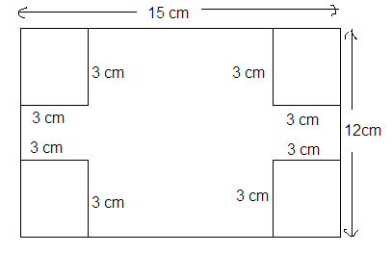
- Take a sheet of 15 cm x 12 cm and cut four squares of 3cm x 3cm from its all the four conrners.

Now fold it as shown in the following fig.
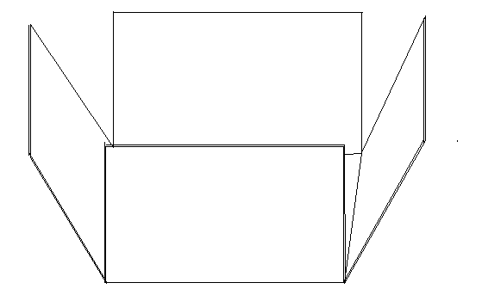

Now your cuboid is ready. Measure it all the dimensions and calculate its total surface area, volume and lateral surface area.

2. Sonu went to a grocer’s shop he purchased some articles. Details of their prices are given in the table, using the following formulae calculate the total amount what Sonu paid to the shopkeeper against these articles:

Sale Tax. = C.P. x $\frac{S.Tax\%}{100}$ ; Discount = C.P. x $\frac{discount\%}{100}$

Amount paid by the customer = [( C.P. + Sale Tax.) – Discount ] X Quantity
for each article

Articles | Cost Price  C.P. | Sale Tax  S.T.% | Discount  Dis% | Quantity | Net Price
Soap | 20.0 Rs | 2% | 5% | 4 | 77.60 Rs.
Biscuit | 50.0 Rs | 5% | 10% | 10 | ……………
Shampoo | 160.0 Rs | 10% | 10% | 2 | …………..
Toothpaste | 45.0 Rs | 2% | --- | 2 | …………..
Hair Oil | 75.0 Rs | 5% | 5% | 1 | ……………
Body lotion | 120.0 Rs | 10% | 15% | 3 | ……………
Room-freshner | 180.0 Rs | 5% | 10% | 10 | …………..
 |  |  |  |  | Total = ………………

Example: i. Sale Tax. = C.P. x $\frac{S.Tax\%}{100}$ = 20 x $\frac{2}{100}$ = 0.40 Rs
ii. Discount = C.P. x $\frac{discount\%}{100}$ = 20 x $\frac{5}{100}$ = 1.00 Rs

iii. Amount paid by the customer = [( C.P. + Sale Tax.) – Discount ] X Quantity
for soap
= [( 20.0 + 0.40) – 1.00] x 4
= [ 19.40 ] x 4
Amount paid by the customer = 77.60 Rs.
for soap

3. Draw an equilateral triangle of side 5cm and cut it out, now make 5 more triangles of same size and cut them out. Write A, B and C at the three corners of these triangles.
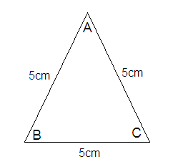

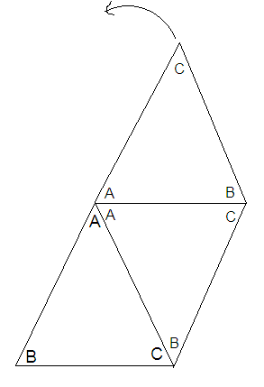
Now place them side by side joining all the corners written A at the same point as shown in the fig.

After joining all the six triangles identify the polygon made by you and name it.

Now measure the angles ∠ B and ∠ C and measure ( ∠ B + ∠ C). Now verify this measurement by using formula:

Each interior angle = (2n – 4) x 90⁰

4. Make a list of different objects/bodies around you which are of the following shapes:

Shape of the body | Name of the bodies (at least four)
- Rectangular shape
2. Cuboidal shape
3. Cubical shape
4. Conical shape
5.Cylindrical shape
6. Circular shape
7. Spherical shape

PHYSICS
Q1. Project:-
Make your own improvised manometer as given on page no. 75 of your text book “New Oxford Modern Science Physics Book 8”.
Q2. a) What characteristics should a vessel being used for cooking have?
b) Draw a graph (Temperature Vs Time) to show the change of states for ice at -
5^{O}C to steam at 110^{O}C.
- From the above graph explain the reason for the regions where graph is parallel to time axis. (temp. constant)
Q3. Draw the diagram for atleast two devices which function due to electromagnetic induction. Also explain its working.

CHEMISTRY
- Write the name and chemical formulae of any five salts which we are using in our daily life. Write their physical properties and uses also.
- Select any five metals of your choice and write the name of their five compounds with their chemical formulae.
- Get information from various sources and make a flow chart to show all the steps of the metallurgy of metal Iron(Fe).
- Write any ten compounds of carbon with their chemical formulae and write their uses also.
BIOLOGY
Note: 1. Attempt any two questions.
2. The written work should be accompanied by a model/ collage.
Q1. Write down a report on “Project Tiger” in not more than 250 words.
Q2. Give a brief account of a “Nuclear Power Plant” in not more than 200 words.
Q3. Write a short note on ‘Drug Abuse’.
HISTORY
Q1. The UNESCO has declared over 600 cultural and natural heritage sites as ‘World Heritage Sites’. Twenty eight of these sites are in India. Make a list of any 10 of these sites in India.
Q2. On an outline map of the world, mark the headquarters of all the specialized agencies of the UN.
Q3. Collect data and pictures on SAARC and prepare an album.
Q4. Discuss Indias Contribution to SAARC. How far has SAARC succeeded in achieving its objectives?

GEOGRAPHY
Q1. Introduction: beginning of the Textile Industry in India.
Q2. The factors that have favoured the location of the textile industry in Mumbai.
Q3. The challenges faced by the textile Industry of Mumbai.
Q4. Make a list of the different regions of India which are known for its designs of weaving.
Q5. On an outline map of India, mark Mumbai and five other important cotton textile centres.

COMPUTER SCIENCE
Q1. What is a database and its advantages?
Q2. Define data abstraction and encapsulation.
Q3. What is data type? Define primitive and reference datatypes.
Q4. Write a program in Java to calculate the circumference and area of a circle having radius 7.5 cm.
(Area = 3.14*3.14*radius, circumference= 2*3.14*radius)

GENERAL KNOWLEDGE
Q1. Answer the following :-
- Who has been named as United Nations Goodwill Ambassador for South Asian region?
- Saina Nehwal won which championship recently?
- Name the city which hosted 9th G20 summit ?
- Which company has set up worlds tallest hybrid wind generator at Kutch ?
- Which village in Varanasi has been adopted by PM Narendra Modi as part of Saansad Adarsh Gram Yojna ?
- With which civilian award was Dr. Manmohan Singh honoured by Japan ?
- Who has been named world's most powerful man for the second consecutive year?
- Who is the Defence Minister of India?
- Indian Shuttler P. V. Sindhu recently successfully defended a title, name it?
- Recently, Phil Hughes died in an unfortunate incident of bouncer, which hit him. Who was the bowler?

VALUE EDUCATION
Q1. Prepare a poster by using important quotes or messages on any one topic:-
- Harmful effect of tobacco.
- Say no to Polythene bags.
- Crime against women.
- Save Wildlife, save humanity.
Q2. Write a paragraph on ‘How you helped a needy or a poor person.’ In about 100 – 150 words.

HINDI
iz”u ƒ& ^^lqHkkxh** dgkuh ds dgkuhdkj dk laf{kIr ifjp; nssrs gq, lqHkkxh ds pfj= dh fo”ks’krkvksa dk o.kZu djsaA
iz”u „& fdlus fdlls dgk&
¼d½ ^^HkS;k egrks] ?kcM+kvks erA Hkxoku us pkgk rks rqe vPNs gks tkvksxsA
¼[k½ ^^csVh] ?kj ns[kdj [kpZ djksA vc dksbZ dekus okyk ugha cSBk gSA vki gh dqvk¡ [kksnuk vkSj ikuh ihuk gSA
¼x½ ^^vkidks csVh cgqr I;kjh gS] rks mls xys ck¡/kdj jf[k,A eq>ls ugha lgk tkrkA
iz”u …& vius NksVs HkkbZ dks iz/kkuea=h }kjk pyk, tk jgs ^^LoPNrk vfHk;ku** dk egRo le>krs gq, mls o mlds lkfFk;ksa dks vius eksgYys ls dwM+k&djdV gVkus o lQkbZ esa fgLlsnkjh ds fy, izksRlkfgr djsaA
iz”u †& vius ns”k dks vktknh fnykus okys fdUgha nks “kghnksa ds fp= ds lkFk muds thou ifjp; rFkk R;kx o cfynku dh ppkZ djrs gq, „‡å “kCnksa esa ,d lqanj ys[k fy[ksaA

SANSKRIT
iz”u ƒ& vFkZ fy[kks&
vof”k’V ] vkokxeue~ ] fØ;k&dyki ] LosPNkpkjh ] tyflDrk ] uhMe~ ] jf”e% ] lUrfr% ] “kL;&”;keyk ] [kspjA
iz”u „& fgUnh esa vuqokn djks&
vga l`’Vs% jpf;rkja oUns & gs izHkks% ekuosH;% ln~cqf)a iz;PNA ekuok% Loj{kkFkZ LodY;k.kk; p o`{kk.kka oukuka p laj{k.ka dq;Z%A rs o`{kkjksi.ka dq;Z ;su oupjk% [kspjk% fuHkZ;k% ifjJeUrqA “kq)% ok;q% ogrqA nso% o’kZrqA tyflDrk /kjk “kL; & “;keyk HkorqA losZ izkf.ku% lqf[ku% lqjf{krk% p lUrqA
iz”u …& “kCn :i fy[ksa& egr~A
iz”u †& “kCn :i loZuke ^^vU;** ¼L=hfyax½ fy[ksaA
iz”u ‡& laLd`r esa mÙkj fy[ksa&
¼d½ losZ i”ko% if{k.k% fda iky;fUr\
¼[k½ /kjk dhn`”kh Hkorq\
iz”u ˆ& fjDr LFkku dh iwfrZ djks&
¼d½ izkr% v:.kL; j”e;% o`{kk.kka f”k[kjkf.k ---------------------------A
¼[k½ if{k.k% ee “kk[kklq ---------------------------------- vjp;u~~A

END

