SAINT JOHN’S ACADEMY
WINTER HOLIDAY HOMEWORK (2014-2015)
CLASS VI
NOTE:- These assignments are to be done on separate answer sheets and submitted to the subject teachers on the first day when the school reopens.

ENGLISH LANGUAGE
Q1. Cut and paste in your language note book any four sentences from the newspaper stating the kind of tense and change each one of them into three different forms and name them.

Q2. Read the passage and answer the following questions:-
Do you complain when you find dirty – trains and stinking compartments? Do you visit paid public toilets often when you travel? Ever got frustrated visiting picnic spots with trash littered all around? How many times do you reprimand the government for its inefficient functioning?
But have you ever thought as to who should be held accountable for such irresponsible deeds? Who makes our country dirty and inhospitable? It is WE, the citizens of India and the fact is we do not take responsibility for our actions. On the other side we start blaming others for all the mess.
The young evolving generation should transform these negativities and take initiatives to bring about a revolutionary change in common man’s mindset. Stop getting frustrated about the present situation and move forward. Think how can you change those situations that disturb you! The visionaries of our independent nation have brought about great changes facing complicated obstacles boldly.
Each of us should take a pledge to be responsible to our motherland. Do not wish for magic to happen, take steps to create your dream world! Son your contribution and the future generations will reap its benefits.
- Pick out two adjectives and state its noun.
- Pick out the words from the passage which means:
- A positive step towards betterment.
- Untidy rubbish dropped in public places.
- Write the antonyms of the following words:-
- Independent (ii) complicated
(iii) forward (iv) inefficient
Q3. Very often, we notice the passive form of the verb in the newspaper headlines. Look up the day’s newspaper and find atleast five instances of the passive voice in headlines.

ENGLISH LITERATURE
Q1. Imagine that you were with the poet, Robert Frost when he was travelling through the woods on a snowy evening. Write a diary entry to describe your experience. Use the guidelines:-
- The location of the woods
- The admiration of the poet for the falling snow
- The puzzled horse who doesn’t know why the poet has stopped.
- The poets love for nature.
- The need felt by the poet to complete all unfinished tasks.

Q2. Find out about Ruskin Bond. Write a paragraph about him and stick his picture.

Q3. Imagine a mysterious visitor comes to your house. Write a paragraph with the help of the guidelines given:-
- Appearance of the visitor
- Details of the visitors behavior
- Details of what happened there
- How everything ended

MATHEMATICS
Q1. Solve these:-
- Ratio of 3.75kg to 750gm.
- Show that 20, 18, 5, 6 are not in proportion.
- Convert into percentage:- (i) (ii) 7.6
- A shop keeper bought a T.V. for Rs.17000 and sold it for Rs.19550. Find his
- Gain (ii) Gain%
- In how many years would a sum of money double itself at 10% per annum?

Q2. Fill in the blanks:-
- 1m³ = …………..cm³
- 1cm³ = …………..mm³
- 1 litre = …………..cm³
- 1m³ = ………….. litres
- Two adjacent sides of a cuboid meet in a line segment called a/ an ……… of the cuboid.

Q3. Draw the pictures of:-
- Equilateral triangle
- Isosceles triangle
- Scalene triangle
- Acute triangle
- Right triangle
- Obtuse triangle
- Cuboid
- Cube
- Triangular prism
- Hexagonal prism
Q4. Complete the following table:-
S.No. | Solid | No. of faces | No. of edges | No. of vertices
(i) | Cuboid/ Cube
(ii) | Triangular Prism
(iii) | Hexagonal Prism
(iv) | Triangular Pyramid
(v) | Hexagonal prism
(vi) | Pentagonal Pyramid
Q5. Write all the formulae of the chapters – 7, 8, 9, 10, 22, 24 & 25

PHYSICS
Q1. Give a brief description of magnet and explain the types of magnets?
Q2. Try to find out the differences between Natural and Artificial magnets and try to give some properties of them.
Q3. With the help of a bar magnet and few iron nails find out which part of the magnets are more powerful among poles and the central region of magnet? Draw a diagram and write your observations.
Q4. Find out with the help of a magnet by hanging it freely with a string that in which direction it always rests. Name the direction in which it always comes to rest or whether it is changing its direction of rest. Explain your observation with the help of a diagram.
Q5. Find out whether it is possible to make an artificial magnet with the help of electricity. If yes, then find out how we can make a magnet using electricity and what it is named as? Give uses of this kind of magnet.

CHEMISTRY
Q1. What is water purification? How can water be made safe for drinking? Explain the methods with the help of a diagram.

Q2. Explain water cycle in nature with the help of a model.
Q3. Water pollution is a major problem. Conduct a survey around your locality to find out the different causes that pollute water and suggest ways and means to prevent it.

BIOLOGY
Q1. Write names of five animals and classify them as invertebrates or vertebrates. Write five characters of each and paste two pictures of animals as examples for each group.

Q2. Compare the different types of soil which are found in India, make a table of the basis of their formation, composition and distribution.

Q3. Fill a tray with loose soil. Fill another with soil taken from a green lawn. Soak both of them with equal amount of water. Drain each of them from the edge. Which tray loses more soil in the wash and why? Many activities of man are increasing soil erosion. What are these activities, write about them.
HISTORY
Q1. Identify the following and write 5 sentences on any 2 of the following pictures given below:-
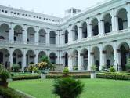
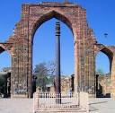
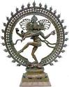
- 2) 3)

4) 5)
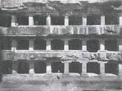
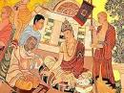

Q2. a) Identify the picture.
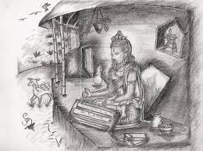
b) What does the picture signify?
c) Name any other sacred book of
this Age (Sangam Age)?

Q3. During bandhs and strikes some irresponsible people damage and destroy buses and buildings. What action do you think should be taken against them? How can such antisocial activities be prevented in the future? Give a pictorial view to support your answer.

GEOGRAPHY
Q1. Study the political map of Africa and represent the following in the form of a model:-
- Capitals of Egypt, Morocco, Nigeria, Kenya, Zambia and South Africa.
- Countries of these capital cities – Tripoli, Kinshasa Lusaka, Windhock and Harare.
- Any five landlock countries.
- Show the different natural vegetative areas (use different coloured papers)

Q2. Paste the pictures for the following and write two sentences on each.
- The large flightless bird common in the Kalahari Desert.
- An animal found in Sahara Desert.
- An animal that lives in swamps.
- The largest living mammals on land.
- An animal found in the Savanna
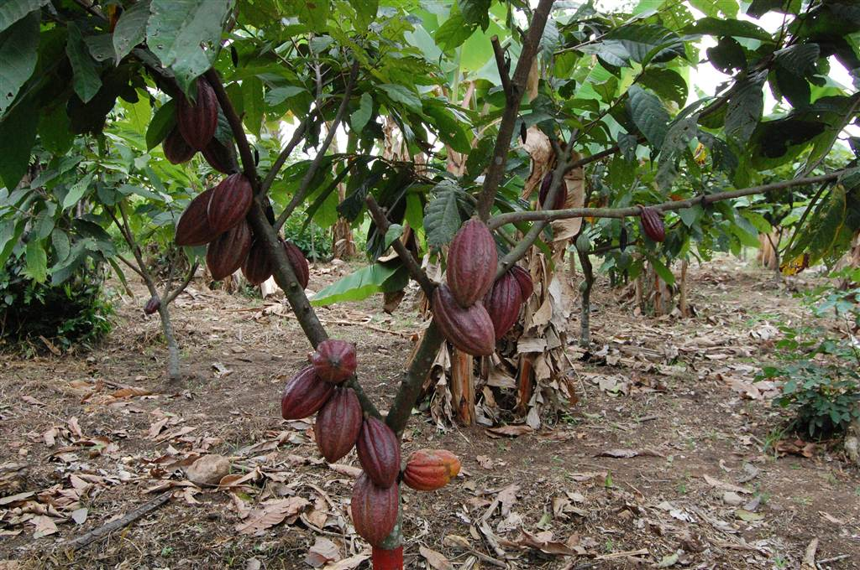
Q3.
- Identify the picture.
- Where is it grown?
- Write any two uses of this plant.

COMPUTER SCIENCE
Q1. Write a short note on history of internet?
Q2. What is E-Mail? And it’s use.
Q3. What is multimedia computer and its uses?
Q4. Draw a sketch diagram of a multimedia computer.
Q5. Explain all the four java tokens with example.
Q6. What is BlueJ?
Q7. Make a flow chart diagram to start sound recorder program in windows XP.

GENERAL KNOWLEDGE
Q1. Write the expanded form of these abbreviations
- ATM 2) BBC 3) FAQ 4) BCE 5) BPL
6) CCTV 7) GMT 8) MLA 9) PIN 10) CD

Q2. Answer the following:-
- Which country became the first country to have successfully launched the satellite on planet Mars on 5th November 2013 which reached Mars on 23rd November 2014?
- When and from where was ‘Swachha Bhartiya Abhiyaan’ launched?
- Which two chief ministers have recently been appointed in the states of Maharashtra and Haryana respectively?
- Which country topped the medal tally in Asian games 2014?
- Which cricketer received Bharat Ratna in 2014?

VALUE EDUCATION
Make a piggy bank for yourself out of a cardboard or a tin box with a lid. Seal all its opening space with cellotape. Make a small slit in the middle of the box and decorate it. Now save money regularly. After saving a handsome amount try and present something to a needy person. Click a picture and paste on your piggy bank.

HINDI
iz”u ƒ& dksbZ ,d i= fy[ksa&
¼d½ fe= dks tUefnu ij c/kkbZ nsus ds fy, i= fy[ksaA vki dkj.k Hkh crk,¡ fd mlds tUefnu ij D;ksa ugha igq¡p ldsA
vFkok
¼[k½ “khr vodk”k esa vius fe= dks vius ikl cqykus fd fy;s i= fy[ksaA
vFkok
¼x½ Kkuon~/kZd o euksjatd if=dk e¡xokus ds fy;s fon~;ky; dh iz/kkukpk;kZ dks izkFkZuk i= fy[ksaA
iz”u „& dksbZ ,d fuca/k fy[ksa&
¼d½ fon~;kFkhZ thou esa fe=ksa dh D;k mi;ksfxrk gS\
¼[k½ le; vewY; gSA blds nq:i;ksx esa lQyrk dk jgL; fNik gSA bl dFku dks Li’V djrs gq, yxHkx „åå “kCnksa esa fuca/k fy[ksaA
iz”u …& ¼d½ Hkwy x;k gS D;ksa bulku dfork ds }kjk dfo us D;k Li’V fd;k gS\
¼[k½ euq’; & euq’; esa lfn;ksa ls Hksn & Hkko D;ksa pyk vk jgk gS\
iz”u †& fuEufyf[kr “kCnksa ds nks&nks i;kZ;okph fy[kks&
la?k ] “kjhj ] LoPN ] /kjrh ] iadt
iz”u ‡& foykse “kCn fy[ksa&
fcxkM+uk ] vfHk”kki ] viw.kZ ] rhoz ] izxfr

SANSKRIT
iz”u ƒ& vuqokn dk;Z djks&
vge~ o`{k% ,o onkfeA ee~ ,rkfu Qykfu vfi [kxsH;%] ekuosH;% lfUrA ijksidkjk; ,o ee thoue~ vfLrA fpfdRldk% vfi vkS’k/kkFkZe iq’ik.kke~ iz;ksxe~ dqoZfUrA ije~ tuk% dk’.k; eke~ d`UrfUrA
iz”i „& mfpr insu mÙkjr&
¼d½ o`{kk% Lo;e~ dq= fr’BfUr\
¼[k½ o`{kk% dL; Nk;ke~ dqoZfUr\
¼x½ o`{kk.kke~ dkfu ijkFkkZ; lfUr\
¼?k½ ds lRiqL’kk% bo lfUr\
iz”u …& fjDr LFkkukfu iwj;r&
¼d½ cky% ------------------------------ cfg [ksyfrA ¼x`ge~ @ x`gkr~½
¼[k½ ckfydk ----------------------- =L;frA ¼okujs.k @ okujkr~½
¼x½ ,d okuj% ckfydk;k% gLrkH;ke~ ---------------- u;frA ¼iqLrde~ @ iqLrdkfu½
¼?k½ okujk% o`{ksH;% ---------------------------- =ksR;fUrA ¼i=kf.k @ Qykfu½
iz”u †& ^ Qye~ * ¼uiqaldfyax½ dk “kCn :i fy[kksA
iz”u ‡& vl /kkrq yV~ ydkj ¼orZeku dky½ fy[kksA

END

