SAINT JOHN'S ACADEMY, ALLAHABAD
CLASS 3, HOLIDAY HOMEWORK 2014 – 2015
SCIENCE
NAME : _ _ _ __ _ _ _ _ _ _ _ __ _ _ _ _ _ _ _ __ _ _ _ ADM.CODE_ _ _ _ __ _ _ ROLL NO._ __ _
[TO BE DONE ON THE SHEET ITSELF]

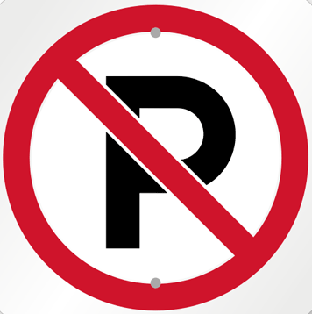
1) Find out what these symbols stands for ?

2) Read the chapter ‘Soil’ (Pg : 68 to 72) from your science book and answer the following questions:
Q.1) Why do farmers add manure to the soil ?
Ans.

Q.2) Why is clay not good for plants however paddy grows well in this soil ?
Ans.

Activity :
Take three pots. Fill one with sand, the other with clay and the third with loam. Put some bean seeds in each pot. Put the pots in the open for a week and water them twice a day.
After one week write your observation.
P.T.O
[PAGE 2]

3) Bring rocks from different places like sides of the road, river banks etc. Wash them with water and soap. Now examine the rocks and write in the columns provided :

Colour | Texture | Any prints found it.

*-*-*

CLASS III SEC ….. MATHEMATICS
NAME : _ _ _ __ _ _ _ _ _ _ _ __ _ _ _ _ _ _ _ __ _ _ _ ADM.CODE_ _ _ _ __ _ _ ROLL NO._ __ _
- If today is Tuesday. What will it be the day after tomorrow ? _ _ _ _ _ _ _ __ _
- If 3rd Match is a Monday, what will be the day on 17th March of the same year ? _ _ _ _ _ _ _ _
3) Write whether the following activities can be completed in hours / minutes or seconds :
- To have a bath : _ _ _ _ _ _ _ __ _
- To blink your eye : _ _ _ _ _ _ _ __ _
- To come back from school : _ _ _ _ _ _ _ __ _
- To eat food : _ _ _ _ _ _ _ __ _
4) Observe the figure carefully and fill in the numbers of :
Circles : _______
Triangle : ______
Square : _______

5) Read the problem and tick the operation, then solve the problem :
Q.1) 4 buns in one tray. How many buns in 16 such trays ?
a) + b) – c) X d) ÷
Answer _ _ _ _ _ _ _ __ _
Q.2) Some boys share 84 marbles equally. If there are 4 boys, how many marbles did each boy get ?
a) + b) – c) X d) ÷
Answer _ _ _ _ _ _ _ __ _
6) Identify the shape of these objects :
Log of wood _ _ _ _ _ _ _ __ _
Globe _ _ _ _ _ _ _ __ _
Ice cube _ _ _ _ _ _ _ __ _
Match box _ _ _ _ _ _ _ __ _
7) In the clock given below read the time and express it in two ways :
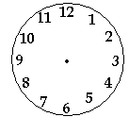

8) Name the shapes :
- A solid shapes with three sides : _ _ _ _ _ _ _ __ _
- A plane shapes with three sides : _ _ _ _ _ _ _ __ _
p.t.o

[page 2]
9) Look at the objects and complete the table :
 | Object | Shape | No. of. Faces | No. of edges | No. of vertices

Use the pictograph given below to answer the questions (Hint each = 10 children):
Favourite food item
Object | Shape
Sandwich
Pizza
Idli
Dosa
Sev Puri
Noodles

- How many children like sandwiches ? _ _ _ _ _ _ _ __ _
- How many children like pizza ? _ _ _ _ _ _ _ __ _
- Which food item is liked by 35 children ? _ _ _ _ _ _ _ __ _
- How many food items are there ? _ _ _ _ _ _ _ __ _
- Which food item is the favourite of all the children ? _ _ _ _ _ _ _ __ _

CLASS III SEC …. COMPUTER SCIENCE :
NAME : _ _ _ __ _ _ _ _ _ _ _ __ _ _ _ _ _ _ _ __ _ _ _ ADM.CODE_ _ _ _ __ _ _ ROLL NO._ __ _
1) Answer in one word :
- Key used to erase a character left to the cursor :
- Inventor of QWERTY keyboard :
- Keys used to move the cursor on the screen :

2) Write the total number in which following keys are present on the keyboard (count & write) :
1) Alphabet keys : _ _ _ _ _ _ _ 2) Enter keys : _ _ _ _ __ _
3) Number keys : _ _ _ _ __ _ 4) Arrow keys : _ _ _ _ __ _
5) Shift keys : _ _ _ _ __ _ 6) Function keys : _ _ _ _ __ _
3) Write the use of the following navigation keys :
End
Home
_ _ _ _ _ _ _ __ _ _ _ _ _ _ _ _ __ _

_ _ _ _ _ _ _ __ _ _ _ _ _ _ _ _ __ _
Ctrl
Ctrl
End

_ _ _ _ _ _ _ __ _ _ _ _ _ _ _ _ __ _
Home
_ _ _ _ _ _ _ __ _ _ _ _ _ _ _ _ __ _
4) What is the difference between Alphabet keys and Number keys ?
Ans.

5) Draw and colour the following keys :
Enter key : Backspace key :

Arrow key : Shift key :

Tab key : Spacebar key :

*-*-*end-*-*-*
CLASS III SEC…. ENGLISH LANGUAGE
NAME : _ _ _ __ _ _ _ _ _ _ _ __ _ _ _ _ _ _ _ __ _ _ _ ADM.CODE_ _ _ _ __ _ _ ROLL NO._ __ _

1) Unscramble the following words with the help of clues given in the brackets and write them correctly :

1) thgaer : _ _ _ _ _ _ _ __ _ (to collect) 2) dlcerea : _ _ _ _ _ _ __ _ (to announce)
2) Write two words each beginning with the following:
1) lo : loyal _ _ _ _ _ _ _ __ _ _ _ _ _ _ _ _ __ _
2) po : _ _ _ _ _ _ _ __ _ _ _ _ _ _ _ _ __ _ pole
3) Pick and list the verb and adverb from each of the given sentences :
Verb Adverb
1) He is eating the fish carefully. _ _ _ _ _ _ _ __ _ _ _ _ _ _ _ _ __ _
2) The soldier marched proudly at the parade. _ _ _ _ _ _ _ __ _ _ _ _ _ _ _ _ __ _
4) Join the following pairs of sentences using conjunctions and rewrite them :
1) I am drinking water. I am thirsty.
_ _ _ _ _ _ _ __ _ _ _ _ _ _ _ _ __ _ _ _ _ _ _ _ _ __ _ _ _ _ _ _ _ _ __ _
2) Is that boy Rohan ? Is that boy Angad ?
_ _ _ _ _ _ _ __ _ _ _ _ _ _ _ _ __ _ _ _ _ _ _ _ _ __ _ _ _ _ _ _ _ _ __ _
3) These flowers are healthy. We water them everyday.
_ _ _ _ _ _ _ __ _ _ _ _ _ _ _ _ __ _ _ _ _ _ _ _ _ __ _ _ _ _ _ _ _ _ __ _
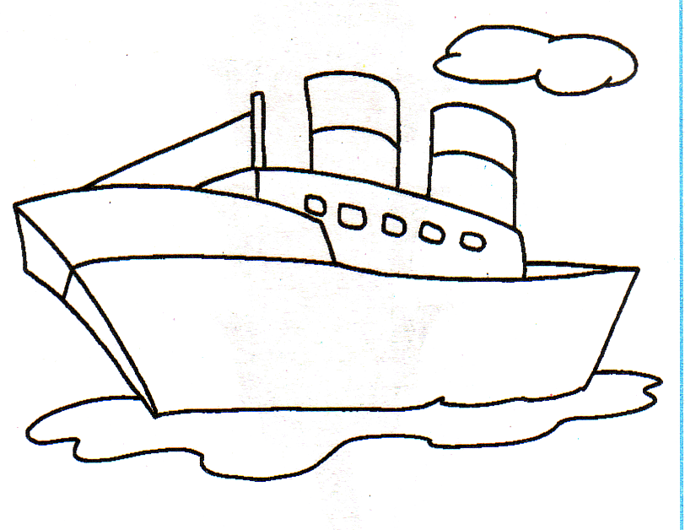
5) Fill in the blanks with the correct form of the verbs given in the ship :
- The baby _ _ _ _ _ _ _ __ _ on the floor. (Present Tense)
- Cats _ _ _ _ _ _ _ __ _ after mice. (Present Tense)
bring, crawl , run ride
- Rita _ _ _ _ _ _ _ __ _ flowers for her friends. (Past Tense)

[TO BE DONE AT THE BACK OF THE SHEET]
Look at the picture and write the story using the given clues (8 lines), write the moral of the story also and give a title to the story :

A fox and crane – fox was cunning – invited crane for dinner – placed a flat dish – the crane has a long beak – could not eat well – the fox lapped – the crane went hungry – the crane invited the
fox – placed a narrow jug – fox could not eat – the crane ate happily – the fox had to go hungry.

TITLE OF THE STORY :

MORAL :

CLASS III ENGLISH LITERATURE
[TO BE DONE ON A SEPARATE SHEET]
1) Make sentences :
1) contest 2) beautiful 3) appeared 4) scolded

2) Read the poem ‘If I could be an astronaut’ and complete the lines :
I wouldn’t go to Venus, _ _ _ _ _ _ _ __ _ _ _ _ _ _ _ _ __ _
_ _ _ _ _ _ _ __ _ _ _ _ _ _ _ _ __ _ _ _ _ _ _ _ _ __ _
_ _ _ _ _ _ _ __ _ _ _ _ _ _ _ _ __ _ _ _ _ _ _ _ _ __ _
_ _ _ _ _ _ _ __ _ _ _ _ _ _ _ _ __ _ _ _ _ _ _ _ _ __ _
_ _ _ _ _ _ _ __ _ _ _ _ _ _ _ _ __ _ _ _ _ _ _ _ _ __ _
Somewhere in the stars.
3) Read Pg. No. 81 and 82 of literature book and answer the questions given below :
- Why was Dadaji angry ?
- What did Saumya find near the pumpkin plant ?
- Why was the pumpkin so precious to Dadaji ?
- What was stolen ?

4) Look at the picture on Page 86. Write five sentences about it. You may begin like this :
This picture shows a scene at Mathru’s sweet shop ………………………….. .

CLASS III SOCIAL STUDIES

[TO BE DONE ON A SEPARATE SHEET]

Read chapters (5) “The Air We Breathe” & (6) “The Water We Drink”, (19) “They Help us” from the Social Studies book before beginning this Holiday Homework :

1) Write five causes of air pollution. Each cause should be provided with a suitable picture.
2) Write atleast 10 lines about ‘rain water harvesting’.
3) You have read how some people help us. Can you think about five people who help you ? Paste his / her picture and write about him / her.
*-*-*--*

