SAINT JOHN’S ACADEMY, ALLAHABAD
CLASS I SEC……….. WINTER VACATION HOMEWORK 2014-15
SCIENCE
NAME _ _ _ _ _ _ _ __ _ _ _ _ __ _ _ _ _ _ _ _ _ __ ROLL NO…… ADMCODE…….
Read the chapters (12) Air, (14) Weather & (15) In the sky from your science book.

1) Fill in the blanks :
- The sun rises in the morning and sets in the _ _ _ _ _ _ _ __ _ .
- The _ _ _ _ _ _ _ __ _ is seen at night.
- We like to sit indoor on a _ _ _ _ _ _ _ __ _ day.
- The sun gives us _ _ _ _ _ _ _ __ _ .
- The air has _ _ _ _ _ _ _ __ _ .
2) Draw or paste the 5 sources of water :

Rain Pond Sea River Well

3) Colour the picture given below showing five parts of the earth. Write their names in the given space :

*-*-END--*–

SOCIAL STUDIES
1) Colour the box green for good habits and red for bad habits :
- Say ‘Thank you’ when someone helps.
- Sneeze on somebody’s face.
- Stand in a queue at the bus stand stop.
- Wash your hands before and after meal.
- Write on the walls and furnitures.
- Keep your room clean.
- Keep your room clean.
2) Draw or paste the pictures of places of worship:

Church Temple Mosque Gurudwara

3) Name the three golden words :
1) _ _ _ _ _ _ _ __ _ _ _ _ _ _ _ _ __ _ 2) _ _ _ _ _ _ _ __ _ _ _ _ _ _ _ _ __ _
3) _ _ _ _ _ _ _ __ _ _ _ _ _ _ _ _ __ _
4) Read the chapters (18) Little Bharat , (19) A brave queen & (20) We love Bapu, from the Social Studies book :

Fill in the blanks :
- Mahatma Gandhi was born on _ _ _ _ _ _ _ __ _ .
- Mahatma Gandhi was lovingly called _ _ _ _ _ _ _ __ _ .
- _ _ _ _ _ _ _ __ _ _ _ _ _ __ _ was Bharat’s mother.
- Dushyant was the king of _ _ _ _ _ _ _ __ _ .
- Rani Lakshmi Bai fought with the _ _ _ _ _ _ _ __ _ .
p.t.o

Make any three of the following (PROJECT)
1) Make a model of the traffic lights using a cardboard, chart paper, glaze paper and a shoe box.

2) Make a model (using cardboard, thermocol sheets, straw, cotton, broom sticks etc.) of any one of the following,:
1) A kuchcha house 2) A pucca house
3) An ifloo 4) A house boat

3) Make a first aid-box with the help of the following points:
- Cover a shoes box with a white chart paper.
- Make a + sign with a red tape of colour.
- Put a bandage, 2 band-aids, a small bottle of dettol liquid, a small dettol soap, some ointments, medicines, a pair of scissors and some cotton.

4) Make a model of an early man, using old dolls or a thermocol sheet.

*-*-*

ENGLISH
1) in the blanks with suitable adjectives. Take the help from the box given :
1) As _ _ _ _ _ _ _ __ _ as fire. 2) As _ _ _ _ _ _ _ __ _ as feather.
3) As _ _ _ _ _ _ _ __ _ as a rock. 4) As _ _ _ _ _ _ _ __ _ as an elephant.
5) As _ _ _ _ _ _ _ __ _ as ice. 6) As _ _ _ _ _ _ _ __ _ as the sun.

2) Fill in the blanks with the suitable preposition given in the box :
in , on , under , near , between

3) Make sentences from the words given. One has been done for you:
apple , red , eating 1) The boy is eating a red apple.
sun , sky , shining 2) _ _ _ _ _ _ _ __ _ _ _ _ _ _ _ _ __ _ _ _ _ _ _ _ _
lion , hungry , roaring 3) _ _ _ _ _ _ _ __ _ _ _ _ _ _ _ _ __ _ _ _ __ _ _ _
4) Write the pairing words and draw and colour the pictures for the same :
- Lock and _ _ _ _ _ _ _ __ _
- Table and _ _ _ _ _ _ _ __ _
p.t.o
[PAGE 2]
5) Read the passage and answer the questions :
It is afternoon. Three monkeys are sitting on a tree. They are looking at a boy. He is eating bananas. The monkeys are also eating bananas. The boy throws a peel into the dustbin. The monkeys also throw the peel into the dustbin.
Q.1) | What time of the day is it ?
Ans.

Q.2) | What are the monkeys eating ?
Ans.

Q.3) | What is the boy doing ?
Ans.

Q.4) | What do the monkeys do with the peel ?
Ans.

PROJECT :
6) Collect pictures of any 5 things and paste them in a scrapbook on different pages.
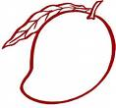
Write 5 sentences for each picture using describing words.
e.g. The mango is yellow is colour.
It has a sweet taste.
It has one big seed.
It is a summer season fruit.
It is called the king of fruits.

*-*-END-*-*-
MATHEMATICS
1) Fill in the blanks using the following objects to measure your mathematics book.
- My maths book is _ _ _ _ _ _ _ __ _ crayons long.
- My maths books is _ _ _ _ _ _ _ __ _ erasers long.
- My maths book is _ _ _ _ _ _ _ __ _ matchsticks long.
2) Take the help of your parents and answer these questions :
- Your weight = _ _ _ _ _ _ _ __ _ kg.
- Your height = _ _ _ _ _ _ _ __ _ feet.
3) Look at the items and answer the following questions :
` 20
Dairy Milk
` 30
` 5
` 2

- Which is the costliest item ? _ _ _ _ _ _ _ __ _
- Which is the cheapest item ? _ _ _ _ _ _ _ __ _
- What is the total cost of an ice-cream and a chocolate ? _ _ _ _ _ _ _ __ _
- If you have Rs 50 note. Which two items can you purchase in that amount ? _ _ _ _ _ _ _ __ _ and _ _ _ _ _ _ _ __ _
4) Name the shapes used in making this picture :
1) _ _ _ _ _ _ _ __ _
2) _ _ _ _ _ _ _ __ _
3) _ _ _ _ _ _ _ __ _
4) _ _ _ _ _ _ _ __ _
5) _ _ _ _ _ _ _ __ _

p.t.o

[PAGE 2]

5) Colour the clock and label the hands of the clock :

The time is _ _ _ _ _ _ _ __ _ .
I _ _ _ _ _ _ _ __ _ at this time.

6) Visit a shop in your neighbourhood for a week. Make a list of seven items that you purchase everyday. Find out the total of all the items purchased :
Day | Items purchased | Amount
Monday
Tuesday
Wednesday
Thursday
Friday
Saturday
Sunday
TOTAL

*-*-end

COMPUTER SCIENCE
1) Find out 5 words from the box given below. Colour each word with different colours
1) _ _ _ _ _ _ _ __ _
2) _ _ _ _ _ _ _ __ _
3) _ _ _ _ _ _ _ __ _
4) _ _ _ _ _ _ _ __ _
5) _ _ _ _ _ _ _ __ _
I | N | P | A | I | N | T | E | R | T
F | E | N | S | O | M | U | U | V | O
L | D | V | W | X | S | T | S | F | M
O | A | M | A | C | H | I | N | E | O
P | T | S | T | U | O | O | K | C | U
P | A | H | C | L | I | C | O | Y | S
Y | T | E | H | T | E | R | B | M | E
U | V | X | T | U | V | A | B | M | R

2) Who am I ?
- I help to draw a square. I am a _ _ _ _ _ _ _ __ _ .
- I help to rub when you make a mistake. I am a _ _ _ _ _ _ _ __ _ .
- I can fill colours in a closed part of the drawing. I am a _ _ _ _ _ _ _ __ _ .
3) Which tools will you use to draw the following in Paint program :
1) _ _ _ _ _ _ _ __ _
2) _ _ _ _ _ _ _ __ _
3) _ _ _ _ _ _ _ __ _
4) _ _ _ _ _ _ _ __ _
5) _ _ _ _ _ _ _ __ _

4) Colour the objects which are used as storage devices :
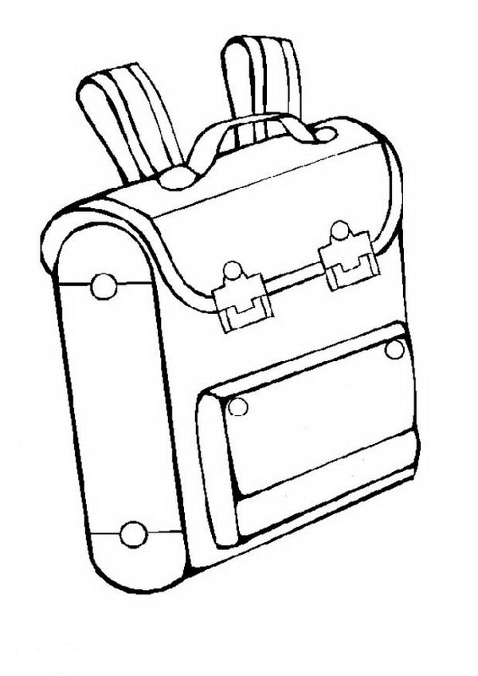

Table
Tree
School Bag

[PAGE 2]
5) Paste or draw the pictures of a Pen drive and CD in the space given below :

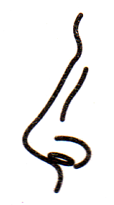
6) Write the name of the pictures. Pick the first letter of each of the word in the same order and will get the name of a storage device :
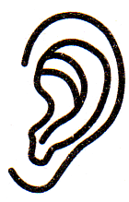
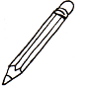
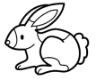
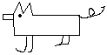

*-*-*END-*-*-*

