SAINT JOHN’S ACADEMY, ALLAHABAD

Class – PRE-NURSERY RECAPITULATION SHEET 2014–15

Name **:……………………………………………** Roll **…………**

ACTIVITY

1) Colour the fruits with the correct colours.

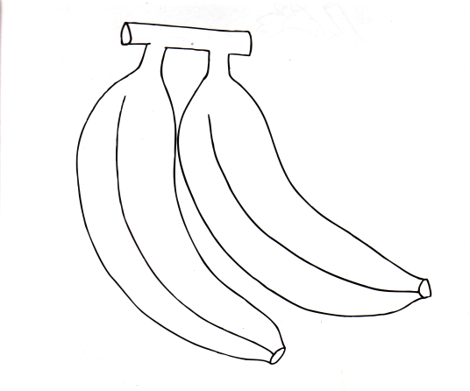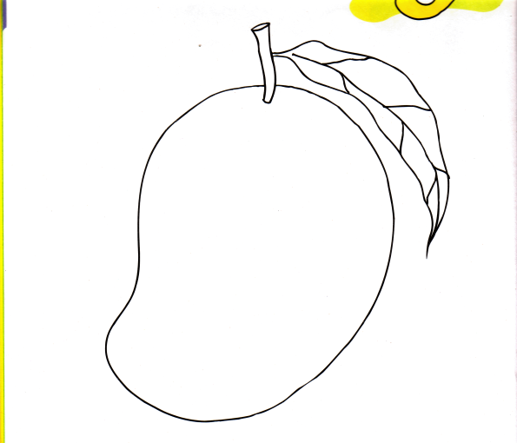

2) Colour the vegetable with the correct colours.

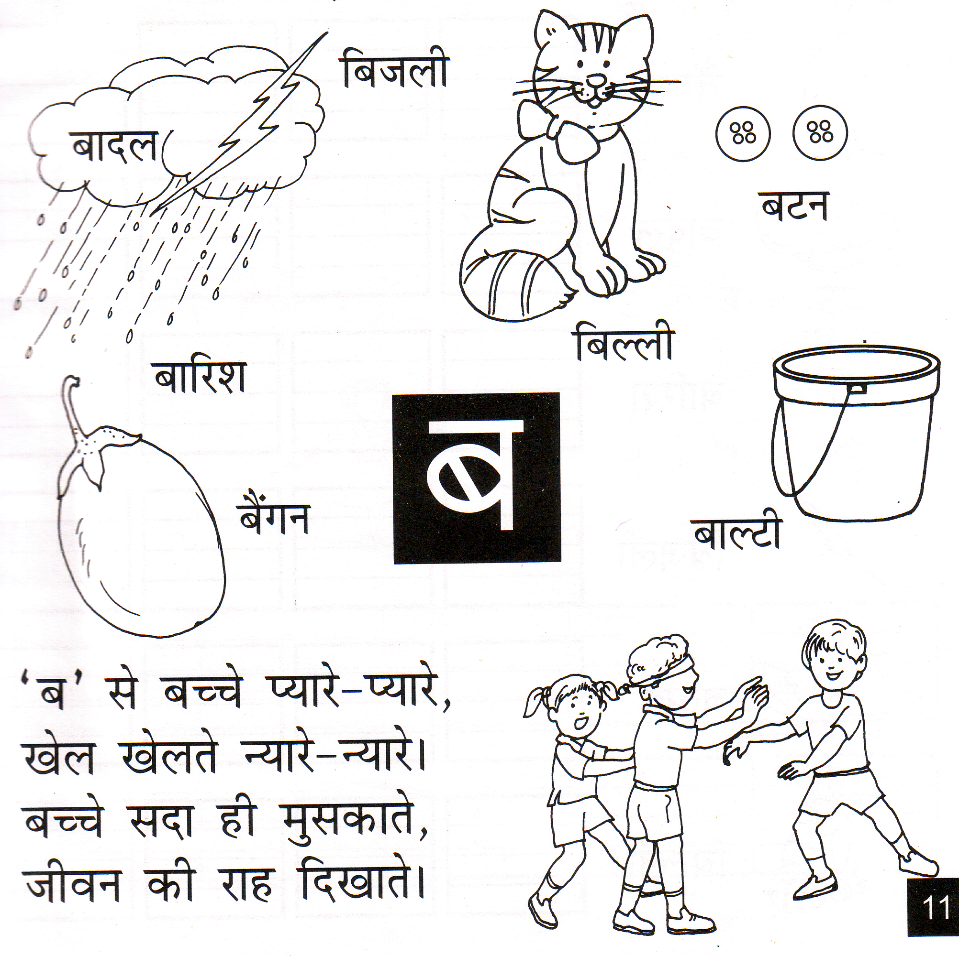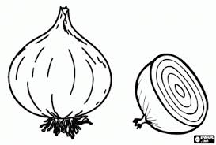

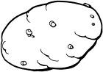

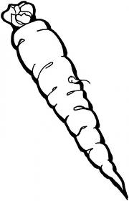

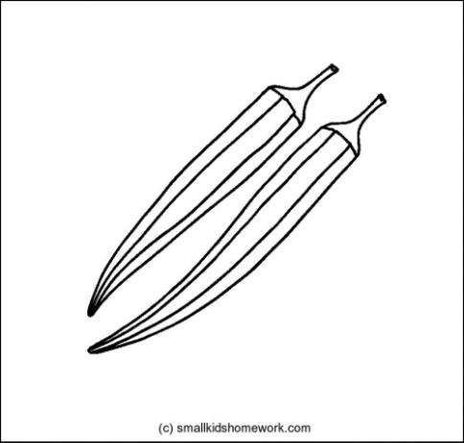

ENGLISH

1) Join the dots, colour and trace the lines with the same colour.

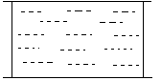

2) See the alphabet and circle the correct picture:

|  |  |  |  |
| --- | --- | --- | --- |
|  | I | P-15 |  |

|  |  |  |  |
| --- | --- | --- | --- |
|  | L |  | lion3 |

|  |  |  |  |
| --- | --- | --- | --- |
|  | H |  | http://t2.gstatic.com/images?q=tbn:ANd9GcTU3qOzywrawm1ZQMkUZ-xQaHPUcEvDrqGZ4Jw_5ii3L3ddcPfwZw |

|  |  |  |  |
| --- | --- | --- | --- |
|  | T |  | http://t2.gstatic.com/images?q=tbn:ANd9GcQIzo-ZsH7LXhFmYQRho07tfhMXtLRShf-k0O4_gaqJyX2utoidlQLFj-ML |

3) Trace the line and colour the ball with the colours mentioned:

NUMBERS

1. Trace the lines and complete the numbers :

2) Colour only two kites

3) Colour the bigger one red and the smaller one yellow:

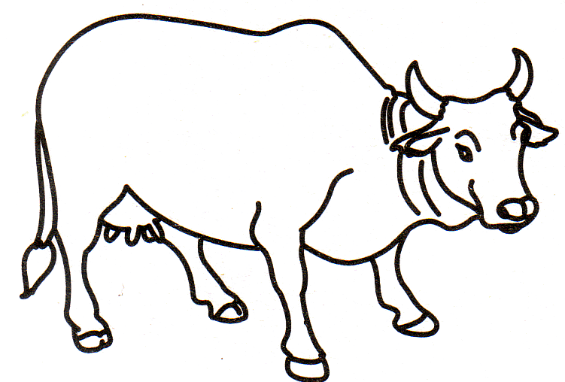

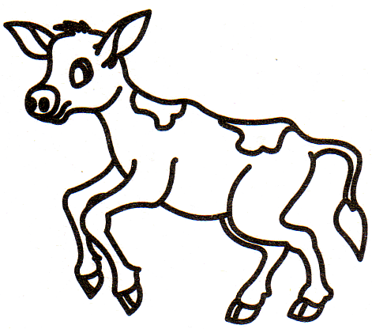

ART / DRAWING

1) Trace the line and colour the sun:

*-*-*

2) Trace the lines and colour the butterfly :

Subject : Hindi

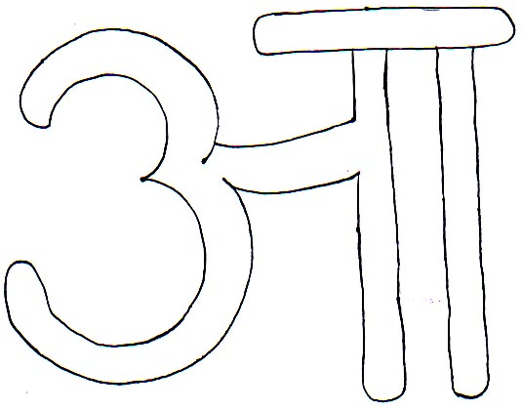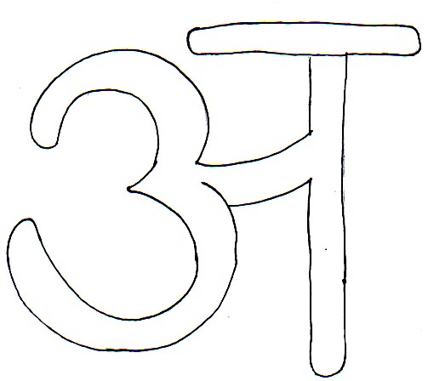iz”u ƒ& v{kj esa jax Hkjks&

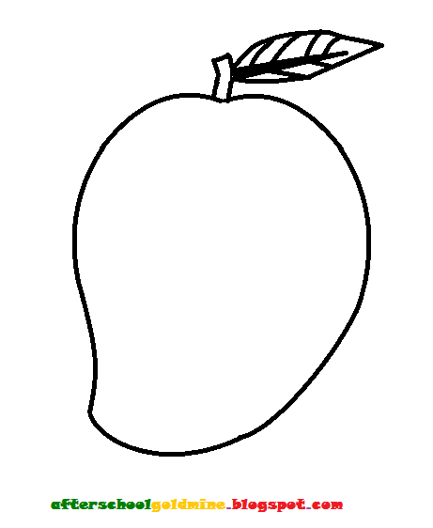iz”u „& fp=ksa esa jax Hkjks&

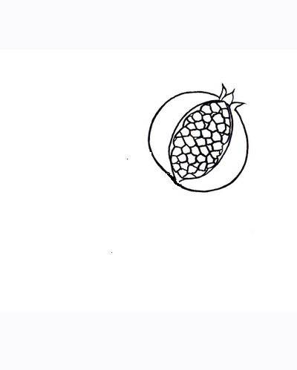

¼lekIr½