SAINT JOHN’S ACADEMY
SUMMER RECAPITULATION (2014-2015)
CLASS VI
NOTE:- These assignments are to be done in separate answer sheets and submitted to the subject teachers on the first day when the school reopens.

ENGLISH LANGUAGE
Q.1. Write an essay of around 150 words on the following topics:
(a) My Holidays.
(b) If I were a tiger….
(c) A school picnic.
(d) Write a story beginning with the sentence ‘It was a dark night and it was raining
heavily….’

Q.2. Write a letter on the following:
(a) Write a letter to your Games’ Instructor requesting him to excuse you from the games and P.T. classes. Also mention the reason and duration of leave.
(b) Write a letter to your cousin telling her/him about the latest book that you have read and why it appealed so much to you.

Q3. Read the passages and answer the questions that follow:

- I had some very naughty friends at school. They were popular because of the pranks they played. All of them were handsome boys and my seniors. This unforgettable incident occurred on my birthday. As usual as I was late for my class that day. I rushed in without meeting any of my friends. But little did I know about the surprise in store for me.
As we were all listening, three of our senior friends entered the class, singing the ‘Happy Birthday’ song for me. They gave me a long neatly wrapped present and coolly went away.
With fifty pairs of curious eyes fixed on me, I was forced to open the gift packet then and there. It turned out to be a metre long snake gourd. Everyone burst out laughing and I too joined them. This is one birthday in my life which I can never forget. Believe it or not, I have that wonderful vegetable with me till now. It always reminds me of my unique birthday.

a) What were the naughty school friends of the narrator well-known for?
b) What surprise birthday gift did he receive?
c) What forced the narrator to open the present then and there?
d) Why has the narrator preserved that birthday present?
e) Supply a suitable title for the incident narrated.
f) Pick out words from the passage having similar meaning to:
(i) happened (ii) in higher classes (iii) eager
g) Pick out adjectives from the passage which have been used to describe:
(i) incident (i) birthday (iii) eyes
h) Pick out adverbs from the passage which have been used to describe:
(i) went (ii) wrapped (iii) reminds

B)
“The great advantage of early rising is that one can start one’s work long before others. The early riser has done a large amount of hard work before other men have got out of bed. Early in the morning the mind is fresh and no sounds or noises disturb our attention. The work done at that time is generally well done. Also one finds time to take some exercise in the fresh morning air. Exercise supplies him with a good deal of energy that enables him to work hard until the evening. By beginning so early, he knows that he has plenty of time to do his work thoroughly. He does not have to hurry over any part of his work. He gets to sleep long before midnight. At that time sleep is most refreshing. After a nights sound rest, he rises early next morning in good health ready for the labour of a new day”.

- What advantages does an early riser have over others?
- Why should one take exercise in the morning?
- Why should one begin the work so early?
- What are uses of going to sleep long before midnight?

Q4. Write the definition of ‘A sentence’ and the types of sentences with two examples each.

ENGLISH LITERATURE
Q1. Memorize the poem ‘The Jumbo Jet’. Write the summary of the poem in your own words.

Q2. Read the chapter ‘The River Bank’. Pick out all the nouns and write their types.

Q3. Read chapter ‘A Handful of Salt’. Write down all the difficult words and their meanings. Make your own sentences from these words. (Atleast 15 sentences)

MATHEMATICS
QI. Make a chart on sets and its types with examples.

QII. Choose the correct answer. (Write only the answer in the answer sheet donot copy the questions)
1. H.C.F of 18 and 24 is
(a) 6 (b) 18 (c) 24 (d) none of these
2. L.C.M of 36 and 48 is
(a) 12 (b) 144 (c) 48 (d) none of these
3. 1965 is divisible by
(a) 3 (b) 5 (c) both a & b (d) none of these
4. The factors of 15 are
(a) {1,3,5,15} (b) {15,30,45…..} (c) {3,5} (d) none of these
5. 43929 is divisible by
(a) 3 (b) 5 (c) 9 (d) both a & c

QIII. Solve :-
Q1. Find the sum of the place values of 9 in 539924.
Q2. Write 7145680 in expanded form.
Q3. Write in words (Indian Number System): 60538791.
Q4. Write the greatest and smallest eight digit number without repeating digits.
Q5. Write in ascending order -47,0,-9,900,4,45.
Q6. Find the difference between the least and the greatest five digit numbers.
Q7. Write all the 2 digits prime number.

Q8. Find the H.C.F. of :-
a) 5,60 and 70. b) 585, 330, 420. c) 345,726 and 531.

Q9. Find the L.C.M. of :-
a) 24,36,54,60. b) 35,25,45,75.
Q10. Find the smallest number which when divided by 45 and 60 leaves 7 as the remainder in each case.
Q11. The L.C.M. and H.C.F. of 2 numbers are 252 and 6 respectively. If one of the number is 42. Find the other number.
Q12. The L.C.M. and H.C.F. of 2 numbers are 360 and 12 respectively. If the bigger number is 72. Find the smaller number.
Q13. Using divisibility test determine if 4100448 is divisible by 4,6,9.

QIV. Solve :-
Q.1. If a = 8 , b = 2 and c = 3 find the value of (16bc - 5ab)/(abc-3b²)
Q.2. If x = 4 and y = 2 find the value of x² - 2xy + y²
Q.3. If a = 3 , b = 2 and c=-4 find the value of 2a+3b-5c
Q.4. Find the value of 3x³ - 9x² - x + 8 when x = 2
Q.5. Find the value of 2x⁴ - 5x³ + 7x - 3 when x = 3

PHYSICS
Q1. Write and learn all the definitions from the chapters ‘Introduction to Physics’ and ‘Measurement’.

Q2. Do you know these famous personalities? What are they known for:-
- Galileo Galilei e) Albert Einstein
- Issac newton f) C.V. raman
- Thomas Alva Edison g) S. Chandrashekhar
- Marie Curie
Q3. Do Activities on Pg. 19 & 20.

CHEMISTRY
Q1. Write the symbols of any 25 elements.

Q2. Draw and write about any 10 common laboratory apparatuses used in Chemistry Laboratory.

Q3. Green plants are called autotrophs. Diagrammatically show the process of photosynthesis.

Q4. Write the formula for (i) Carbon dioxide (ii) zinc sulphide (iii) Magnesium oxide
- Sodium chloride (v) water (vi) copper sulphide

BIOLOGY

Q1. Draw & practice the labeled diagrams (any two) of “Food Chain”.
Q2. Write and learn all the definitions from the chapters ‘Our Environment’; ‘Life on earth’ and ‘Classification of living world’.
Q3. List the names & characteristics of any two examples each of the different types of plants
- On the bass of size
- On the basis of nutrition
HISTORY
Q1. Define the following:-
- Parchment 2) Historians 3) Civics 4) Diversity 5) Numismatics
Q2. Identify the dance forms and in which regions did they originate?
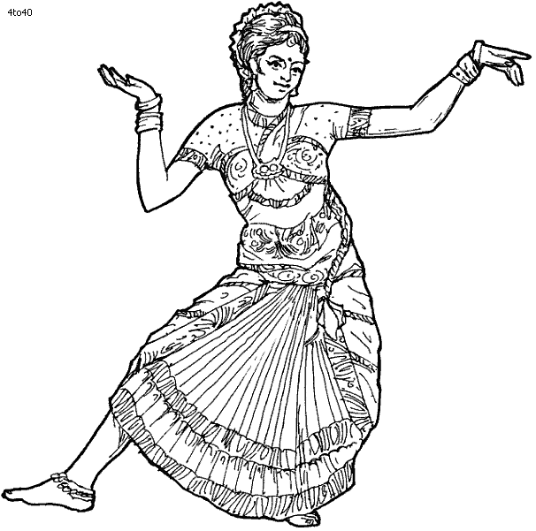
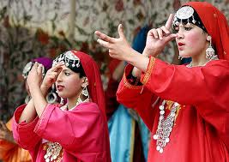
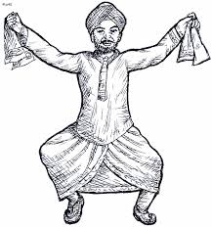
- (ii) (iii)

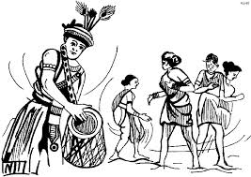
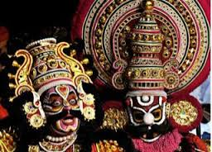
(iv) (v)

Q3. Do ‘Picture Study’ as given on page no. 14, 22 & 30 as given in your History & Civics book.

GEOGRAPHY
Q1. Which types of maps would you use to show the following:-
Districts; cities; lakes; conventional symbols; plateaus; wind direction, historical places; mineral; crops; temperature.

Q2. Define the following:-
- Representation fraction (b) Plan (c) Thematic maps
(d) Linear scale (e) Cartography

Q3. Identify the following conventional symbols:-

- PS (b) RS (c) (d) (e)

Q4. Do Activity on page no. 8.

COMPUTER SCIENCE
- Create a Power Point Presentation – [ Bring the presentation in a pen drive ]
Contents of Presentation-
  - My Self
  - My Friends
  - My Family
  - My Hobbies
- Give your views on “Why is Windows XP more popular than other Operating Systems?”
- Create your class time table in MS-Word using Draw Table option and give a suitable format to your table with the help of Table Auto-Format. [ Bring the MS-Word document in a pen drive ]
- List the various Computer Hardwares and Softwares. Write a short note on each of them with examples.
GENERAL KNOWLEDGE
Answer the following questions:-
- What is the player holding in the IPL Trophy?
- In 1930, where was the first FIFA World cup held?
- In which state is Kakori, the site of a historical dacoity?
- Which country won the 2013 Women’s cricket world cup?
- Which NASA satellite detected calcium deposits on Mars in 2013?
- Which revolutionary did Ajay Devgan play in a 2002 film?
- What is the famous ‘Marine Drive’ in Mumbai also referred to as?
- The ‘Tiananmen Square’ is located in which city?
- A film based on which Chetan Bhagat’s book was released in 2013?
- Which Indian Olympian does Farhan Akhtar potray in the film ‘Bhaag Milka Bhaag’?
- Which is the highest civilian award in India?
- The newly appointed chief of Indian navy.
- Name of Malayasian Aircraft which has yet not been able to locate?
- Which team won T-20 world cup in 2014?
- Who won man of the series in T20 world cup in 2014?
- The International Airport at Port Blair is named after which Leader?
- Which is the First team to win five Fifa World Cups over the years?
- In new Delhi, what was Albukud Marg renamed as in honour of Mahatma Gandhi?
- ‘Champs – Elysees’ is a board avenue in which city?
- Write the full form of W.W.W.

VALUE EDUCATION
Q1. What is obedience? To whom should you be obedient and why?
Q3. You elder brother has always aspired to become a pilot. But your parents want him to become an engineer. If he listens to them, what will be the outcome.
Q4. During Summer vacation, you would like yourself to volunteer for any kind of service to your nation. Which one you would choose. Make a project in support of your answer.

HINDI
  
 
 
 
  
   



➢


 
 
 
 ➢

SANSKRIT
iz”u ƒ& mfpr “kCn Hkjks&
¼d½ ----------------------- vkj{kd% vfLeA ¼vge~ @ Roe~½
¼[k½ ----------------------- urZd% vflA ¼vge~ @ Roe~½
¼x½ vge~ -----------------------A ¼iBkfe @ iBfl½
¼?k½ Roe~ -------------------------A ¼uekfe @ uefl½
¼³½ --------------------------- ekrk vfLeA ¼vge~ @ Roe~½
¼p½ --------------------------- iq=h% vflA ¼vge~ @ Roe~½
¼N½ o;e~ oSKkfudk% ----------------------A ¼Le% @ LFk½
iz”i „& laLd`r “kCnksa ds fganh vFkZ fy[kks&
rjFk ] d`tke% ] ipkfe ] /kkokfeA
iz”u …& fganh esa vuqokn djks&
¼d½ vge~ lSfud% vfLeA
¼[k½ Roe~ d% vflA
¼x½ vge~ xt% vfLeA
¼?k½ Roe~ HkYywd% vfLrA
¼³½ o;e~ HkDrk% Le%A
¼p½ ;w;e~ fde~ dq:FkA
iz”u †& ^ iB~ * /kkrq ^ yV~ ydkj * dk izFke% iq:’k%] e/;e% iq:’k% o mRre% iq:’k% dk cgqopu :i fy[kksA

END

