SAINT JOHN'S ACADEMY, ALLAHABAD
CLASS …….. SEC……. RECAPITULATION WORKSHEET 2014 – 2015
ABACUS LEVEL 1
NAME : _ _ _ __ _ _ _ _ _ _ _ __ _ _ _ _ _ _ _ __ _ _ _ ADM.CODE_ _ _ _ __ _ _ ROLL NO._ __ _
[TO BE DONE ON THE SHEET ONLY]
1) Place the value on the bar :
4
9
7
6

2) Write the friends of :
5

2
5
1

5
4

3) Write the value of beads :

4) Abacus calculation :
1
1
5
1
2
5
5
2
– 1
4
– 2
1
1
2
– 3

5) Label the parts of Abacus :
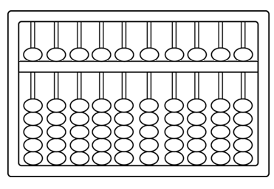

*-*-*-END-*-*

SAINT JOHN'S ACADEMY, ALLAHABAD
CLASS …….. SEC……. RECAPITULATION WORKSHEET 2014 – 2015
ABACUS LEVEL 2
NAME : _ _ _ __ _ _ _ _ _ _ _ __ _ _ _ _ _ _ _ __ _ _ _ ADM.CODE_ _ _ _ __ _ _ ROLL NO._ __ _
[TO BE DONE ON THE SHEET ONLY]
1) Write the Small Friend formula :
+ 4 = |  |  | – 1 =

+ 1 = |  |  | – 3 =

+ 2 =

2) Draw the beads for the given value :
28
47
59
68
35

3) Write the Big Friend formula :
+ 1 = |  |  | − 3 =

+ 6 = |  |  | – 2 =

+ 2 = |  |  | – 5 =

+ 8 = |  |  | – 4 =

+ 3 = |  |  | – 9 =

p.t.o
[PAGE 2]
4) Mental calculation :
6
– 5
3
8
– 2
– 5
2
– 1
3
3
2
– 5
2
2
4

5) Abacus calculation :
2 9
– 7
3
3 6
– 8
– 9
3 0
– 6
8
2 5
8
4
1 6
– 1
8

*-*-*end-*-*

SAINT JOHN'S ACADEMY, ALLAHABAD
CLASS …….. SEC……. RECAPITULATION WORKSHEET 2014 – 2015
ABACUS LEVEL 3
NAME : _ _ _ __ _ _ _ _ _ _ _ __ _ _ _ _ _ _ _ __ _ _ _ ADM.CODE_ _ _ _ __ _ _ ROLL NO._ __ _
[TO BE DONE ON THE SHEET ONLY]
1) Write the combination formula :
+ 8 = |  |  | + 9 =

– 6 = |  |  | – 8 =

– 7 =

2) Mental calculation :
2
5
7
1
8
7
– 4
2
– 3
9
5
9
6
4
1
8
– 4
9
– 6
7
2
5
4
8
3

3) Multiplication :
 | 8 | X | 3 | = |  |  |  |  |  | 2 | X | 3 | =
 | 7 | X | 8 | = |  |  |  |  |  | 4 | X | 2 | =
 | 4 | X | 0 | = |  |  |  |  |  | 5 | X | 7 | =
 | 5 | X | 2 | = |  |  |  |  |  | 2 | X | 9 | =
 | 3 | X | 6 | = |  |  |  |  |  | 8 | X | 5 | =

4) Abacus calculation :
2 4
3
6 5
– 1 7
8 0
– 9
2 8 5
6 4 1
4 0 8
7 3 6

3 9 7
6 4 2
9 1
– 7 5
8
– 2 0
6 4
3

*-*-**

SAINT JOHN'S ACADEMY, ALLAHABAD
CLASS …….. SEC……. RECAPITULATION WORKSHEET 2014 – 2015
ABACUS LEVEL 4
NAME : _ _ _ __ _ _ _ _ _ _ _ __ _ _ _ _ _ _ _ __ _ _ _ ADM.CODE_ _ _ _ __ _ _ ROLL NO._ __ _
[TO BE DONE ON THE SHEET ONLY]
1) Complete the formula :
+ 6 = | + 1 _______ + 10 |  | − 8 = | – 10 ______ – 3

+ 7 = | ______ – 5 + 10 |  | – 6 = | – 10 ______ – 1

+ 9 = | + 4 – 5 _____

2) Abacus calculation :
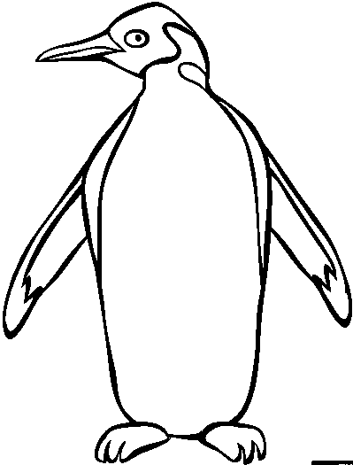

4 2
1 0 0
– 9 8
2 1 3
8 3
9 0 0
– 9 0
– 8 9
3 1
+ 4 4 4
– 3 6 8
+ 4 3 1

4 9
1 8 3
5 6 8
– 2 0 9
2 4
9 3 8
– 3 3 5
2 0 6

3) Multiplication :
5 9 X 8= ____
9 0 X 7 = ____
8 9 X 4= ____
6 0 X 9 = ____
3 6 X 9 = ____

*-*-*-END-*-*

SAINT JOHN'S ACADEMY, ALLAHABAD
CLASS …….. SEC……. RECAPITULATION WORKSHEET 2014 – 2015
ABACUS LEVEL 5
NAME : _ _ _ __ _ _ _ _ _ _ _ __ _ _ _ _ _ _ _ __ _ _ _ ADM.CODE_ _ _ _ __ _ _ ROLL NO._ __ _
[TO BE DONE ON THE SHEET ONLY]
1) Abacus calculation :
6 2 8
9
1 7 3
7 8 4
2
6 5
7
4 1
9 0

4 3 8
5
– 5 9
7
– 3 2 4
8 1
– 2
9 1 6
7 0

6 7 5 4
2 0 9 8
– 8 7 1 9
2 4 0 5
1 5 4 6
6 0 2 9
1 5 8 0
5 3 4 7
– 8 6 1 9
7 2 4 3
5 4 3 1
7 2 6 8
4 0 9 5
9 8 0 6
3 1 7 2

2) Mental calculation :
4
9
– 6
3
6
– 5
7
– 8
1
3
7
5
8
2
5
1
9
4
3 7
4 8
5 9
7 0
9 2
– 5 7
8 1
– 6 4
1 6
7 3
4 0
3 2

3) Multiplication (Mental) : 4) Division (Mental) :
 | 939 | X | 4 | = |  |  |  |  |  | 228 | ÷ | 6 | =
 | 803 | X | 2 | = |  |  |  |  |  | 392 | ÷ | 8 | =
 | 109 | X | 7 | = |  |  |  |  |  | 385 | ÷ | 5 | =
 | 417 | X | 9 | = |  |  |  |  |  | 462 | ÷ | 7 | =
 | 925 | X | 6 | = |  |  |  |  |  | 164 | ÷ | 4 | =

*-*-*-*

SAINT JOHN'S ACADEMY, ALLAHABAD
CLASS …….. SEC……. RECAPITULATION WORKSHEET 2014 – 2015
ABACUS LEVEL 6
NAME : _ _ _ __ _ _ _ _ _ _ _ __ _ _ _ _ _ _ _ __ _ _ _ ADM.CODE_ _ _ _ __ _ _ ROLL NO._ __ _
[TO BE DONE ON THE SHEET ONLY]
1) Abacus calculation :
1 7 0 5
6 9 8 4
– 2 3 1 7
8 0 5 6
7 4 9 2
– 3 8 6 0
4 1 2 9

5 1 7 8
3 4 9 0
6 0 2 1
7 8 3 5
1 9 4 6
2 7 8 5
9 2 0 4

9 2 1 4
3 5 7 0
– 1 4 2 9
5 8 0 6
7 3 4 1
– 6 0 9 5
8 7 3 2

3 5 0 1
6 7 4 8
2 0 9 5
1 4 3 7
5 9 8 0
4 6 1 2
8 3 7 9

4 0 2 8
7 9 1 5
– 6 2 3 0
5 8 4 1
3 5 9 7
– 1 2 0 6
8 4 7 9

2) Mental calculation :
1 6
7 2
8 5
4 0
3 9
5 8
6 5
– 2 3
7 0
1 8
– 4 7
9 6
7 8
4 9
2 0
6 1
3 5
8 2
9 2
– 7 5
3 6
8 0
– 1 7
6 4
7 0
6 3
2 4
9 1
8 0
5 9

3) Multiplication (Mental) : 4) Division (Mental) :
 | 6534 | X | 3 | = |  |  |  |  |  | 3222 | ÷ | 6 | =
 | 1729 | X | 6 | = |  |  |  |  |  | 2335 | ÷ | 5 | =
 | 5006 | X | 7 | = |  |  |  |  |  | 4249 | ÷ | 7 | =
 | 6553 | X | 4 | = |  |  |  |  |  | 1914 | ÷ | 2 | =
 | 6034 | X | 3 | = |  |  |  |  |  | 3060 | ÷ | 4 | =

**-*-*

