SAINT JOHN’S ACADEMY, ALLAHABAD
Class – PRE-NURSERY WINTER VACATION HOMEWORK 2015–16
Name :…………………………………………… Roll …………
[ENGLISH]
1) Circle the correct alphabet for the pictures :

A D C

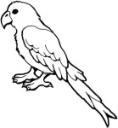
K P B

C V R

2) See the alphabets and colour the correct picture :
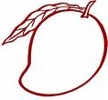
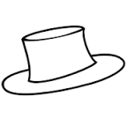
O

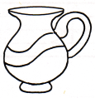

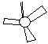
F

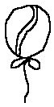
K

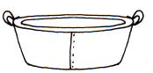
S

3) Join the dots and complete the pictures :

Pg. 1 of 6
[PAGE 2]
4) Fill in the blanks :
E
C
A

Z
T
R
P
N
L
F
H
J

U
W

*-*-END-*-*

Pg. 2 of 6
[E.V.S / ACTIVITY]
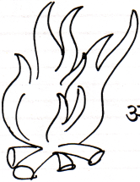
1) Colour the hot objects yellow and cold objects green :
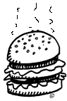

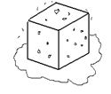
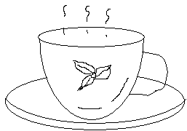
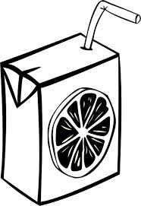

2) Colour the clothes that we wear during Winters:
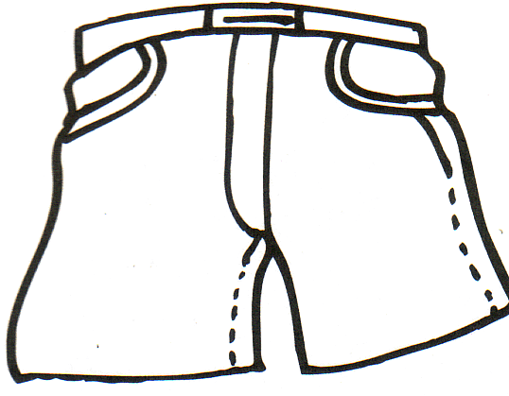
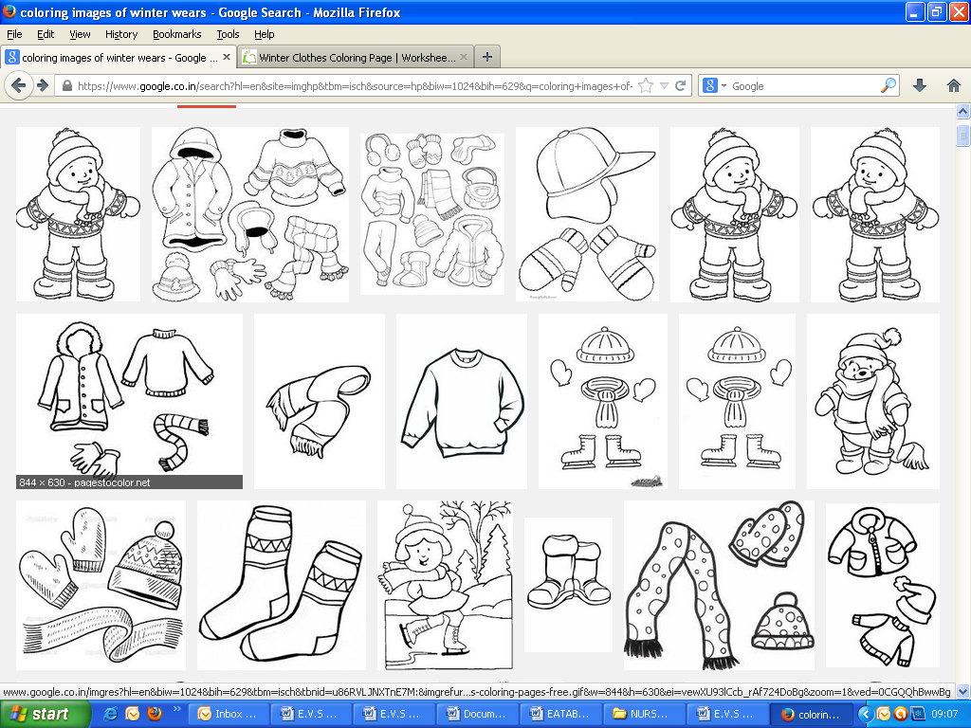
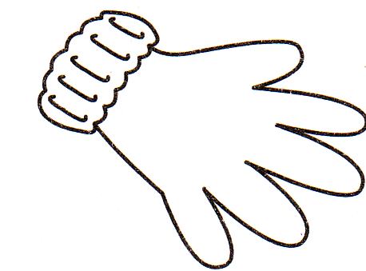

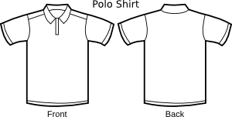

3) Colour the things that we like to eat or drink during the Winter Season :

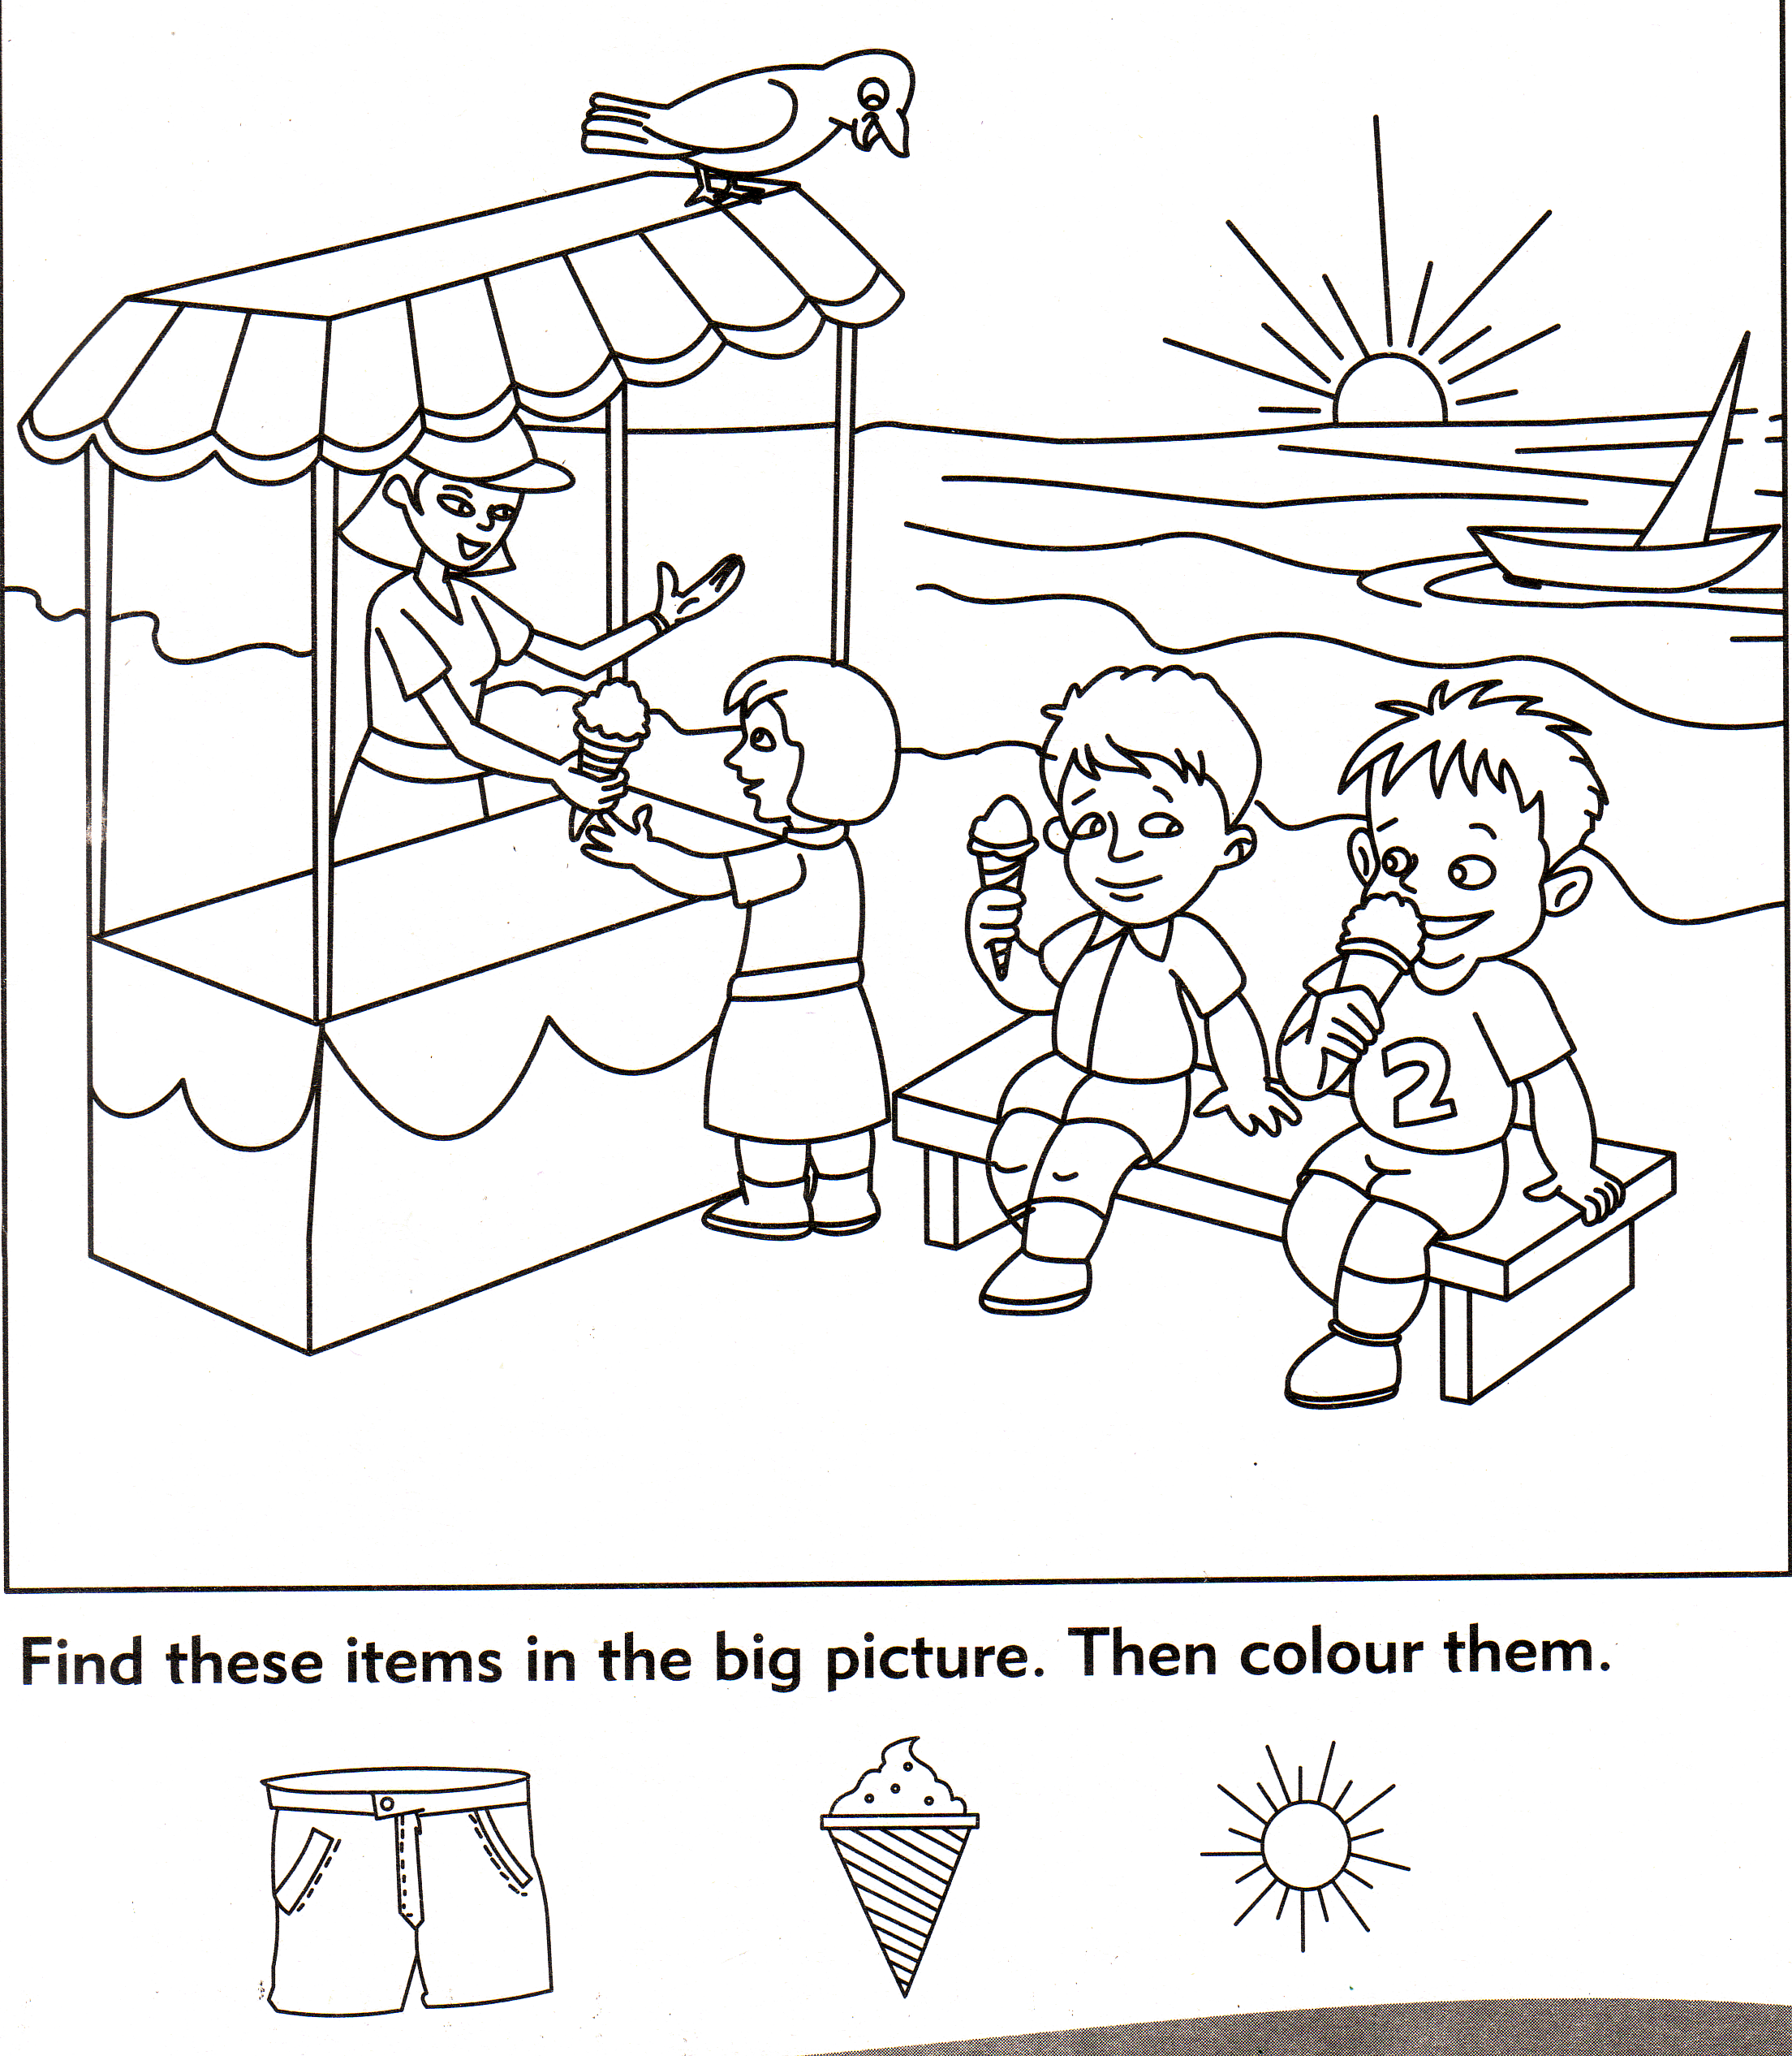
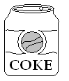

Pg. 3 of 5
*-*END-**
[MATHS ]
1) Write the numbers 1 to 18 :

2) Count the pictures and circle the correct number :
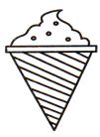
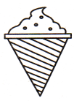
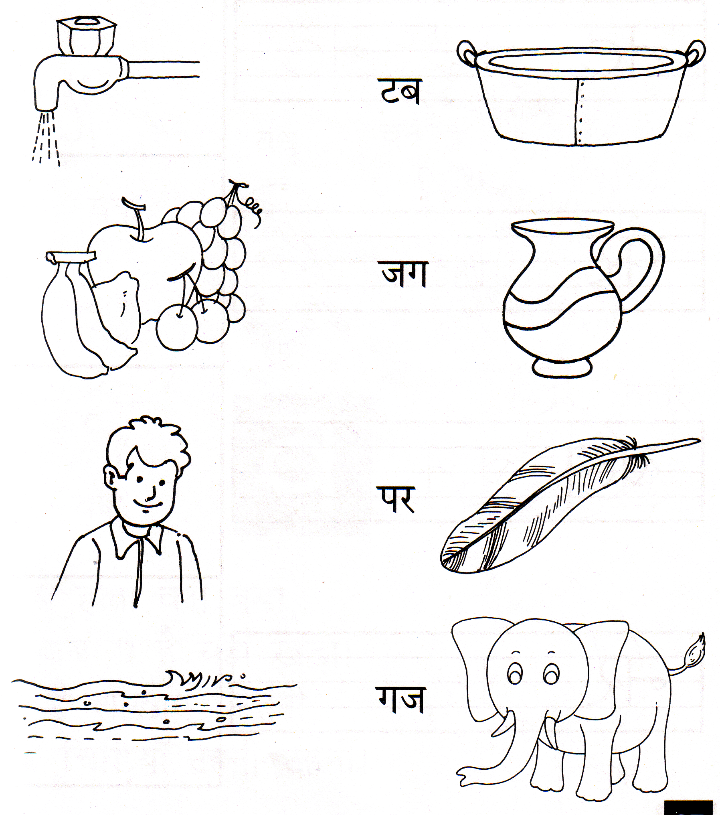
5 6 4
3 5 4
6 5 7
4 3 2
7 8 9
8 7 6

Pg. 4 of 6
[PAGE 2]
5) Colour the thick pencil with red colour and thin pencil with the blue colour :

*-*-END-*-*

