SAINT JOHN’S ACADEMY, ALLAHABAD

CLASS : NURSERY SEC…………. WINTER VACATION HOMEWORK - 2015 – 16

Name : _ _ _ _ _ _ _ __ _ _ _ _ _ _ _ _ __ _ Roll no……………… Adm. Code…………….

**ENGLISH**

**1) Put these words in the right column :**

|  |  |  |  |  |
| --- | --- | --- | --- | --- |
| cot | hut | set | fit | car |
| jet | jar | pit | nut | pot |

|  |  |  |  |  |
| --- | --- | --- | --- | --- |
| ar | et | it | ot | ut |
|  |  |  |  |  |

|  |  |  |  |  |
| --- | --- | --- | --- | --- |
|  |  |  |  |  |

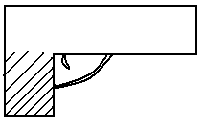**2) Fill in the blanks :**

1. G g is for _ _ _ _ _ _ _ __ _ .
2. K k is for _ _ _ _ _ _ _ __ _ . 
3. S s is for _ _ _ _ _ _ _ __ _ .
4. V v is for _ _ _ _ _ _ _ __ _ .
5. 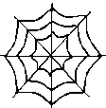M m is for _ _ _ _ _ _ _ __ _ .
6. W w is for _ _ _ _ _ _ _ __ _ .

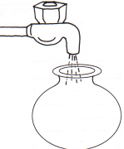**3) Rearrange the jumbled words :**

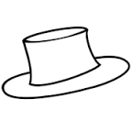 1) geg ___________ 2) otp ____________

3) inp ___________ 4) tha ____________



 5) dgo ____________ 6) naf ____________

p.t.o

[PAGE 2]

**4) Look at the pictures and complete the word ladder :**

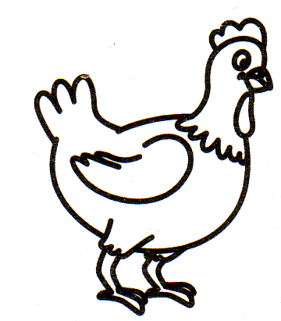

h

n

t

p

t

b

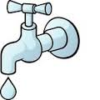

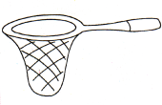

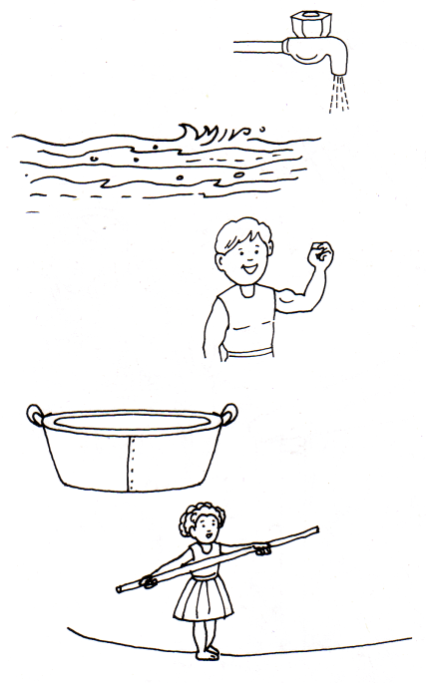

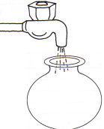

**5) Cross the odd one :**

|  |  |  |  |
| --- | --- | --- | --- |
| bag | hat | mat | rat |
| bin | lip | pin | fin |
| hot | dog | log | fog |
| hut | cut | sun | nut |

**6) Join the dots and colour the picture:**

*-*-END-*-*

E.V.S

**1) Tick the vehicles that have only three wheels ?**

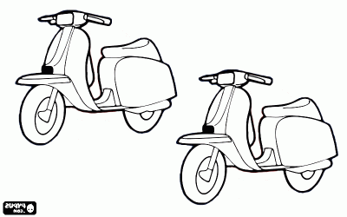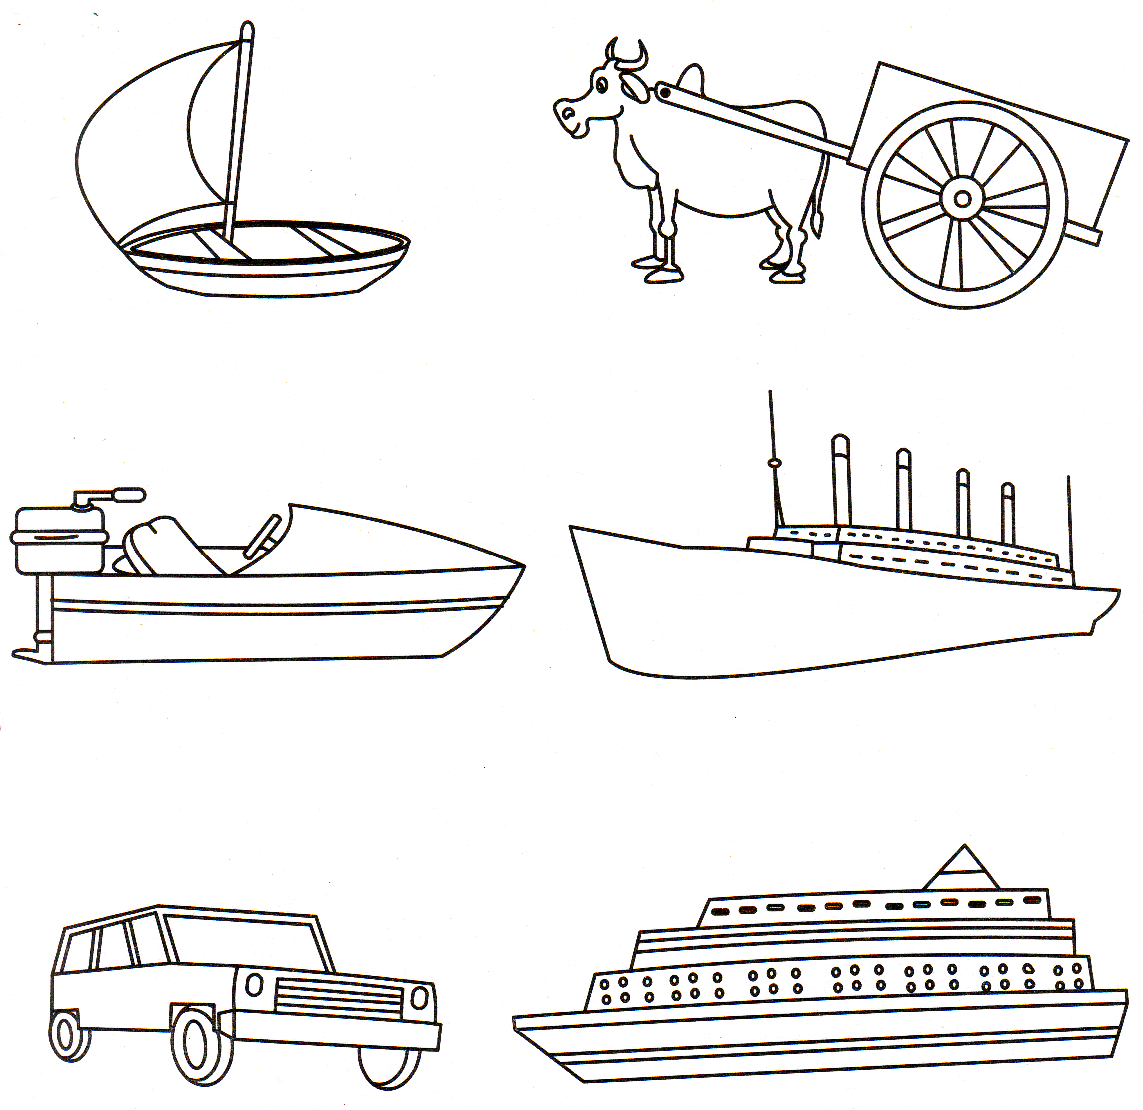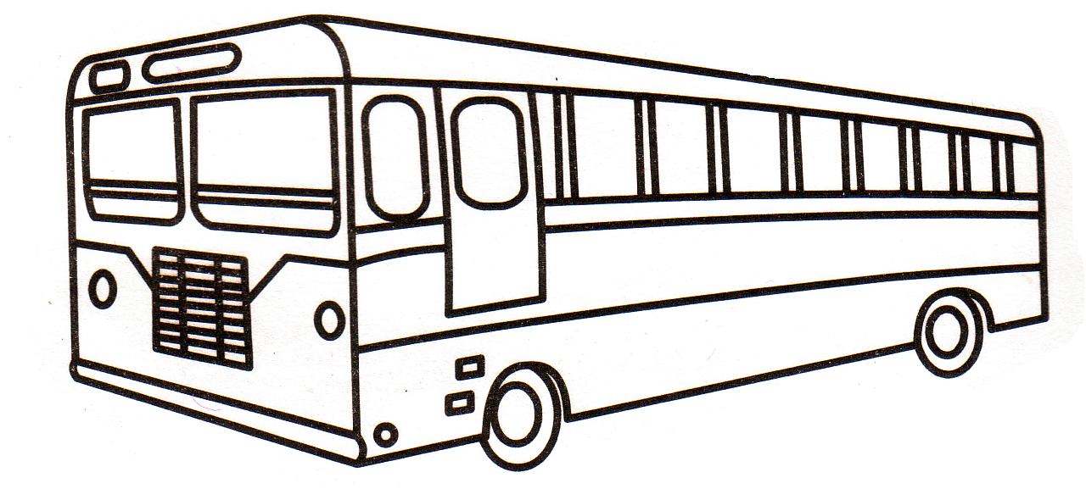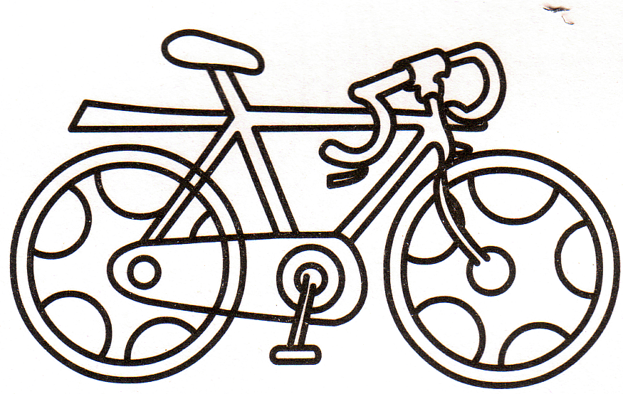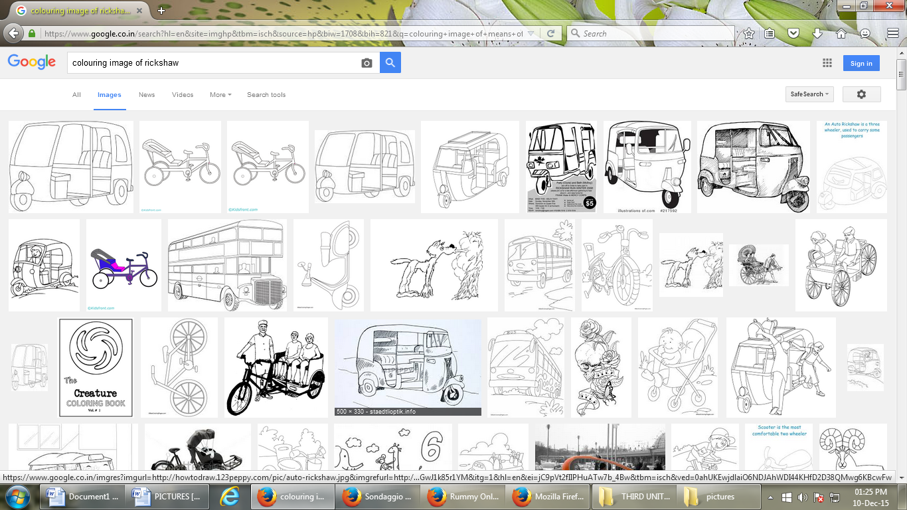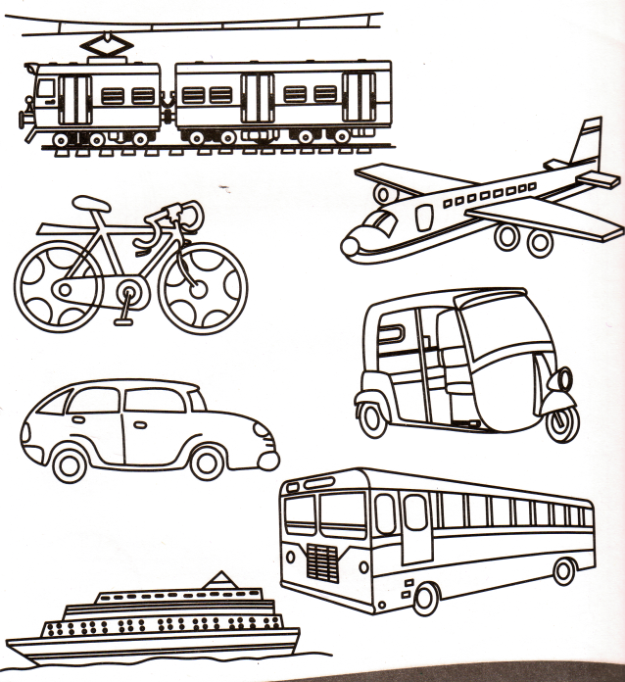

**2) Colour the picture correctly :**

|  |  |  |
| --- | --- | --- |
| black | CROW1 | **http://www.my-coloring-pages.com/images/candy/Chocolate-Candy-Bar.jpg** |
| brown | daisy |  |
| green | gh-1 | lotus1 |
| red |  |  |
| blue |  |  |
| purple | carrot-3-coloring-page |  |

**3) Colour the traffic lights and zebra crossing :**

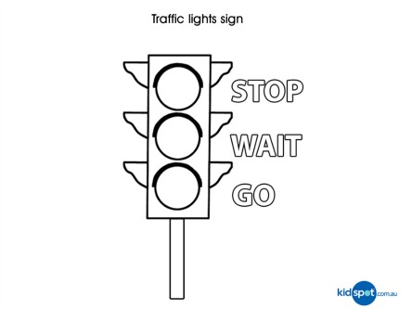

P.T.O

**[PAGE 2]**

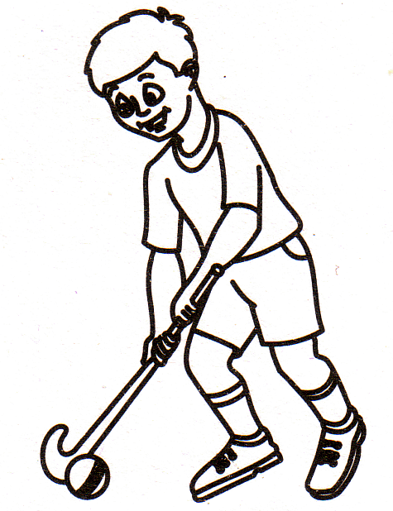**4) Tick ( ) only the indoor games :**

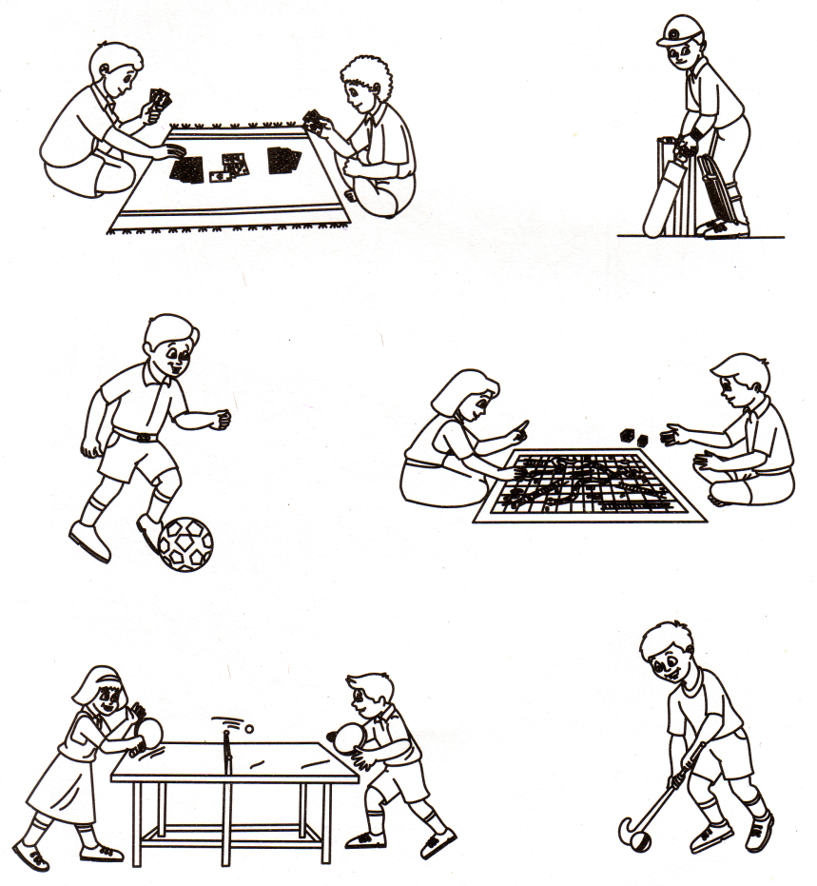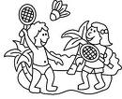

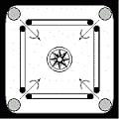

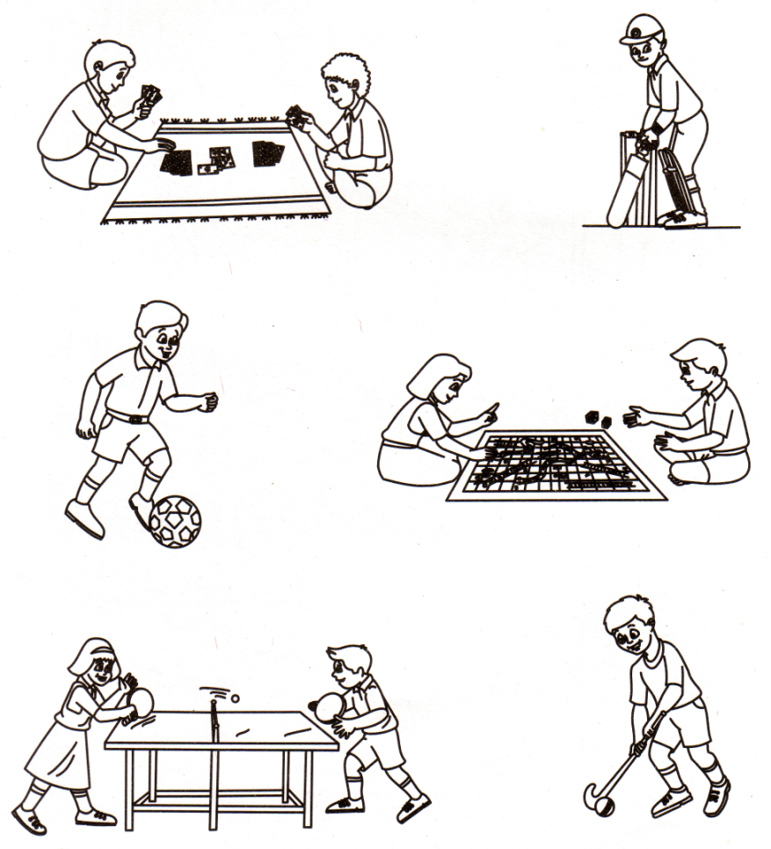

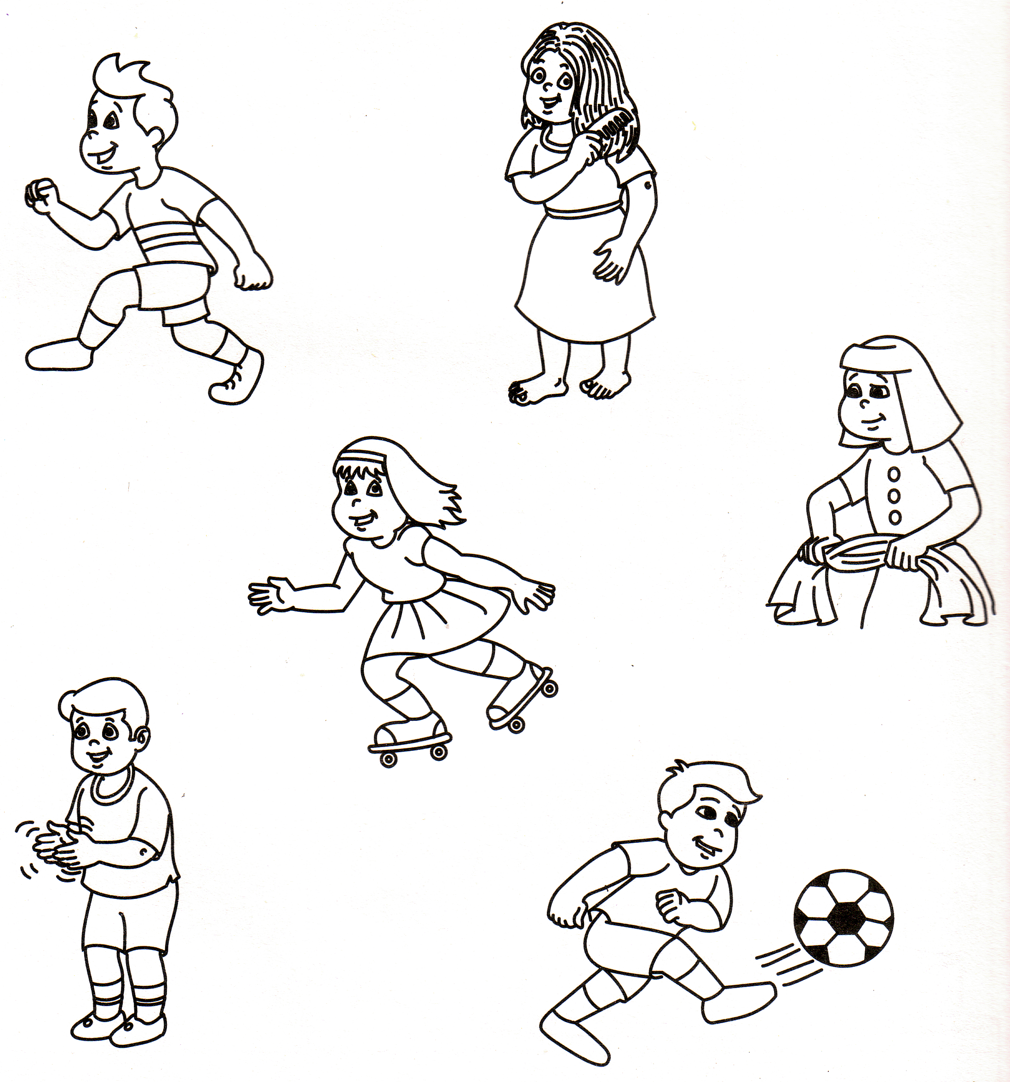

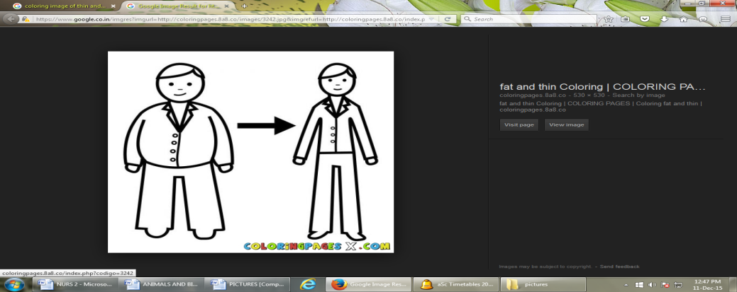**5) Match the opposites :**

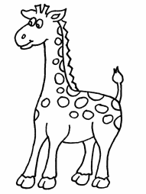

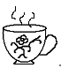

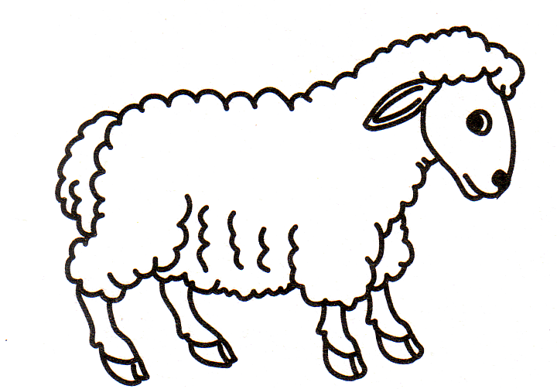

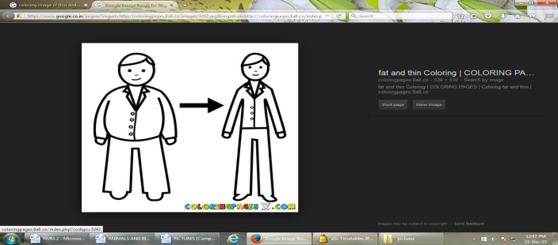

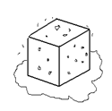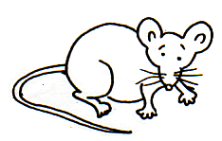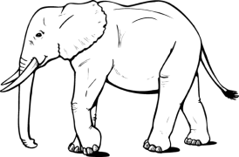

*-*-END-*-*

MATHS

1) Fill in the missing numbers :

35 39

80 83

62 64

2) Colour the heavy one brown and the light one red :

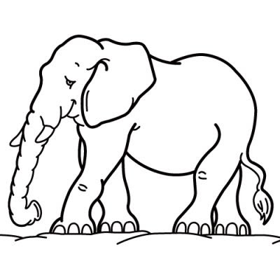

3) Ring the correct numeral :

Twelve 8 12 15

One 11 1 10

Eight 9 7 8

Fifteen 15 14 10

Four 5 7 4

Thirteen 13 12 11

p.t.o

4) Add :

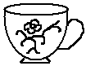

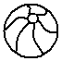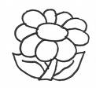

5) Subtract :

6) Colour the shapes using the key given :

square - pink, rectangle- blue, circle- blue, triangle –brown.

*-*-end-*-*