SAINT JOHN’S ACADEMY, ALLAHABAD
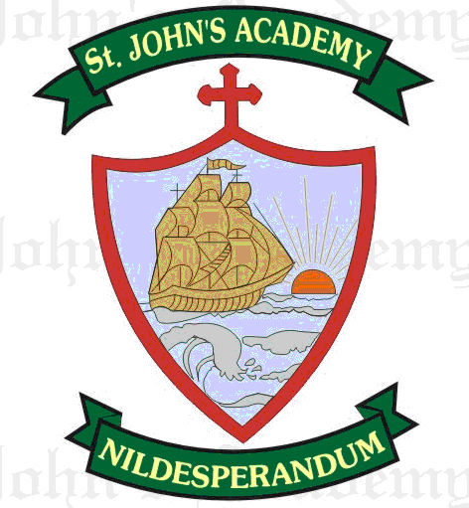
FINAL TERM SYLLABUS 2015-2016
CLASS – VII

 | UNIT TEST | FINAL EXAM
ENGLISH LITERATURE; Dict. & Eloc. | Packing for the journey (11); Rain in summer (12); On being Sarah (13) | Friends & Flatterers (21); The Home Coming (Part I & II) (17, 18)
ENGLISH LANGUAGE | Verb (6); Tense (7, 8, 9); Essay – Narrative; Comprehension | Active & Passive (12); Adverbs (13); Direct & Indirect (16); Letter (Formal & Informal) Essay – Narrative & Imaginative; Comprehension From Prv. Syll. – Prepositions (14)
MATHS | Average (13); Percentage (14); Profit Loss & Discount (15); Linear equations & Inequations (22, 23); Congruency & Constructions of triangles (30, 31) | Simple Interest (16); Polygons (32); Quadrilaterals (33); Circles (34); Perimeter 7 Area (36); Volume & Surface Area (37); Statistics (38)
PHYSICS | Transfer of heat (5); Light and shadows(6) | Reflection of Light (7 ); Electricity (8 )
CHEMISTRY | Chemistry in Everyday life (4) | Acids, Bases, Salts (5)
BIOLOGY | Nutrition in animals and plants (5) ; Ingestion, digestion absorption and assimilation of Food (6) | Respiration in animals & Plants (7); Excretion in animals & Plants (8)
HISTORY | The Vijaynagar & Brahamini Kingdom (9); The Union and state Legislature (20) | Akbar the Great (12); The Union Executive (21); The Judiciary (23)
GEOGRAPHY | The Silicon Valley (10); The Antarctica (17) | South America (12, 13); Pastoral Farming in Argentina (15)
COMPUTER SCIENCE | More on Internet (8); Introduction to HTML (9) | Power Point Advance Features (7); Java Programming (11); Java Decision Making (12)
GENERAL KNOWLEDGE | Page No. 33, 34, 37, 38, 39, 60 ; Current Affairs (10) | Page No. 39, 40, 42, 46, 61, 62; Current Affairs (15); Test Paper – 2; Quiz 5
VALUE ED. | True Wealth (8); Humility is the best of the soul (9) | Friend, Philosopher & Guide (13); The Good Samaritan (14)
HINDI LIT.; LANG. & DICTATION | ty gh thou gS] izfrfnu gks R;ksgkj gekjk ¼dfork½] okD; ds izdkj] dky] i;kZ;okph] eqgkojs] vifBr x|ka”k] fuca/k ys[ku& xaxk iznw’k.kA | va/ksjs dk nhid] cky yhyk ¼dfork½] loZuke ,oa mlds Hksn] fo”ks’k.k ,oa mlds Hksn] fojke fpg~u] rRle&rn~Hko] lekl] vifBr x|ka”k] vukSipkfjd i=&] fuca/k ys[ku& thou esa iqLrd dk egRoA
SANSKRIT | “kCn :i& unh] /kkrq :i& iB~ /kkrq y ydkj ¼Hkwrdky½] lqnkl%A | prqnZ”k% ikB%& dkd% fdeFkZa d`ik%\] =;ksn”k% ikB%& lqo~pukfu] “kCn :i& lk/kq] /kkrq :i& vl~ /kkrq y ydkj ¼Hkwrdky½A
ART | Birds drawing & sketching | Sea Scape (Poster Colour)
SUPW | Bells with holly leaves & cherry | Pencil Holder

