SAINT JOHN’S ACADEMY, ALLAHABAD
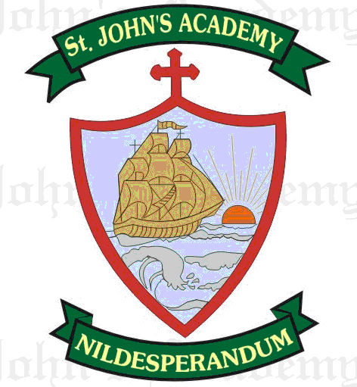
FINAL TERM SYLLABUS 2015-2016
CLASS – VI

 | UNIT TEST | FINAL EXAM
ENGLISH LITERATURE; Dict. & Eloc. | The Song from Heaven (9); Spring Quiet (17) | Stopping By The Woods on a Snowy Evening (22); The Mysterious Visitor (Part I & 2) (18, 19)
ENGLISH LANGUAGE | Verbs (5, 23); The Tenses (16, 20); Essay – Narrative; Comprehension | The Adverb (6, 24); Active & Passive Voice (22); Direct & Indirect Speech (27); Essay – Narrative & Argumentative; Letter (Formal & Informal); Comprehension
MATHS | Ratio and Proportion (7); Percentage (8); Triangle (19); Circles (20) | Profit and Loss (9); Simple Interest (10); Perimeter & Area (22); Solids (23, 24); Statistics (25); From Prv. Syll. - Linear Equations (14)
PHYSICS | Simple Machine (3) | Magnetism (4) ; From Prv. Syll. – Work, Force, Energy (2)
CHEMISTRY | Air (4); Rocks & Minerals (6) | Changes around Us (5) ; Water (7)
BIOLOGY | Classification of animals (4) ; Some Useful Plants & Animals (9) | Structure and Functions of Plant Parts (5); Soil (6)
HISTORY | Urban Local Self Government (21); Rise of Magadha (12) | Preservation of Public Property (22); The Mauryan Empire (13); The Gupta Empire (15)
GEOGRAPHY | New Zealand (8); Sugarcane cultivation in Queens (10) | Africa (11, 12); Cocoa Cultivation in Ghana (15)
COMPUTER SCIENCE | Working with Animations (6); MS Excel – An Introduction (7) | The Internet (8); Multimedia Applications in Windows (9); An Introduction to Java Programming (10)
GENERAL KNOWLEDGE | Page No. 36, 38, 40, 41, 59, 60 Current Affairs (10) | Page No. 46, 57, 61, 62 Current Affairs (15); Quiz
VALUE ED. | Happiness: The essence of life (8); A friend in need is a friend indeed (9) | Humility (11); Perseverance & Hard Work (13)
HINDI LIT.; LANG. & DICTATION | jksekapd leqæh ;k=k ¼ƒŒ½] uhsfr ds nksgs ¼ƒ„½] lekl] foykse “kCn] okD;ka”k ds fy, ,d “kCn] fuca/k& eu ilan _rq] | Hkwy x;k gS D;ksa balku ¼ƒ‡½] vfXuiq=h dks lyke ¼ƒŒ½] laf/k] lekl] fojke fpg~u ,oa mlds Hksn] i;kZ;okph] eqgkojs] vukSipkfjd i=& fuca/k ys[ku& daI;wVj dh mi;ksfxrk] vifBr x|ka”k
SANSKRIT | “kCn :i& yrk ¼L=hfyax½] /kkrq :i& iB~ y`V~ ydkj ¼Hkfo’;r~ dky½] ,dkn”k% ikB% ¼lIreh foHkfDr½A | =;ksn”k% ikB%& prqFkhZ foHkfDr] prqnZ”k% ikB%& iapeh foHkfDr] “kCn :i& Qy ¼uiqald fyax½] /kkrq :i& vl~ /kkrq y`V~ ydkj ¼Hkfo’;r dky½A
ART | Drum Colouring (Poster Colour) | Village Scene with crayon colours
SUPW | Wall hanging; Holly Leaves | Piggy Coin Box

