SAINT JOHN’S ACADEMY, ALLAHABAD
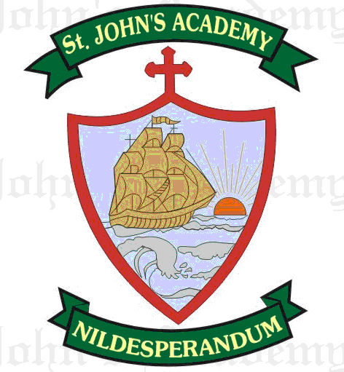
FINAL TERM SYLLABUS 2015-2016
CLASS – V

 | UNIT TEST | FINAL EXAM
ENGLISH LITERATURE & READING | Rescue (16); Rabindranath Tagore (17) | The Treasure Hunt (19); The Mountain and The Squirrel (23)
ENGLISH LANGUAGE | The Verb (12 & 13); Forms of Verbs (14 & 15); Agreement of Verbs with the subject; Comprehension | Adverbs (16 ); Prepositions (18); Conjunctions (19); Articles (20); Punctuation (21) ; Essay – My Hobby; A Festival I Celebrated; Comprehension; Formal Letter  From Prv. Syll: Tenses
SPELLING & DICTATION | Spell List 9 – 12; Seen Passage : Rescue (16); | Spell List 13 – 16; Seen Passage : The Treasure Hunt (19)
WRITING | Page No. 23 – 30 | Page No. 30 – 38
RECITATION | Something Left Undone (15) | The Strange Lingo ; The Mountain and the Squirrel.
MATHS | Average (7); Percentage (8); Algebra (9); Mental Drill 25 – 36 | Perimeter & Area (11); Metric Measures (6); Mental Drill 37 –  From Prv. Syll: Percentage (8); Factors and Multiples (4); Geometry
SCIENCE | Methods of Cooking & Preserving Food (3); Water (14) | Simple Machines (11); Energy (12); Sense Organs (9)
HISTORY | Conquering distances (13); Keeping in touch (14) | The United Nations (21); Governing Ourselves (20)
GEOGRAPHY | Environmental Pollution (10); Caring for our environment (11) | The Land of Sand (8); The Treeless Grasslands (9); Natural Disasters (12)
COMPUTER SCIENCE | Microsoft Power Point 2007 (7); Slide Organization in PowerPoint (8) | MS – Excel 2007 (10); Algorithm & Flowchart (11); Internet & Email (12)
GENERAL KNOWLEDGE | Page No. 34, 35, 37, 38, 40, 43, 46, 48; Current Affairs | Page No. 53, 54, 55, 59, 60, 63, 64, 66, 67; Current Affairs
VALUE ED. | Consideration (7); Politeness Works Wonder! (8) | Compassion (10); Commitment (11)
HINDI LIT.; LANG. & DICTATION | chjcy dh le>nkjh ¼‰½] iq’i dh vfHkyk’kk ¼‹½] i;kZ;okph “kCn] dky] vifBr x|ka”k] okD;] fyax] dgkuh ys[ku ¼f”k{kkizn½]] Spell list 5 & 6; Seen Passage chjcy dh le>nkjh ¼‰½ | gS LoxZ ls Hkh vPNk ¼ƒ‡½] fldanj dk U;k; ¼ƒˆ½] dkjd ¼‹½] fojke fpg~u ¼ƒˆ½] foykse “kCn ¼‡½] vusdkFkZd “kCn ¼‡½] okD;& v”kq)&”kq) ¼ƒ‡½] vkSipkfjd i=& fuca/k& iznw’k.k ds izdkj crkrs gq, gksus okyh gkfu;k¡ rFkk muls cpus dk mik;] Spell list 7 & 8; Seen Passage fldanj dk U;k; ¼ƒˆ½
SANSKRIT | uoe% ikB%& l%] ,’k%]lk] ,’kk ¼d½] n”ke% ikB%& l%] ,’k%] lk] ,’kk ¼[k½] /kkrq :i & iB~ /kkrq y`V~ ydkj Hkfo’;r dkyA | ,dkn”k% ikB%& rs] rk%] ,rs] ,rk%] “kCn :i& ^ckyd*] ipn”k% ikB%& o’kkZ _rq%A
ART | Page No. 34, 35, 36, 39, 40, 41, 42, 45; Sketching of Face: Eyes, Nose, Lips & Ears; Story Drawing “A Clever Fox”; “Grapes are Sour” | Page No. 52, 55, 56, 59, 60, 63, 64, 67; Still Life; Poster Making
SUPW | Paper Quilling lamps | Envelope; Card

