SAINT JOHN’S ACADEMY, ALLAHABAD
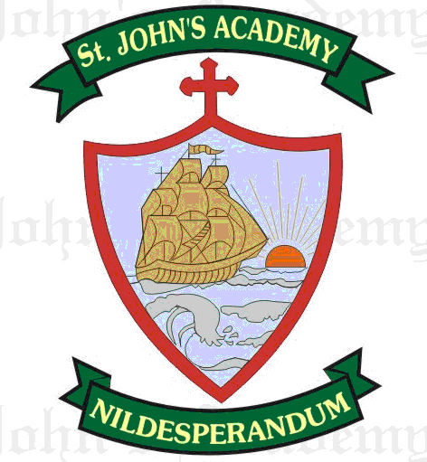
FINAL TERM SYLLABUS 2015-2016
CLASS – IV

 | UNIT TEST | FINAL EXAM
ENGLISH LITERATURE & READING | The Wind (15); My Magic Pot (9) | Mahatma The Great Soul (20); My Mother (23)
ENGLISH LANGUAGE | Adjectives (14, 15); Verbs (16, 17); Prepositions (21); Conjunctions (22); Comprehension | Tenses (19); Adverb (20); Articles 24); Essay – My Parents; My School Campus; Formal Letter; Comprehension From Prv. Syll. :- Parts of Speech (8)
SPELLING | Spell List 9 – 12; Seen Passage : My Magic Pot (9) | Spell List 13 – 16; Seen Passage : Mahatma The Great Soul (20)
WRITING | Page No. 23 – 30 | Page No. 31 – 40
RECITATION | The Wind (15); Choosing Shoes (13) | My Mother (23)
MATHS | Unitary Method (8); Decimal fractions (6); Geometry (Polygons); Mental Drill 25 – 36 | Area & Perimeter (10); Time (9); Geometry (11); Metric Measures (7); Mental Drill 37 – 46 From Prv. Syll. :- Mathematical Operations (4); Decimal Fractions (6); Unitary Method (8)
SCIENCE | Safe Drinking Water (8); Materials and their properties (9) | Force, Work & Energy (10); Soil (11)
SOCIAL STUDIES | The Southern Plateau (5); Our rich heritage (21); Our Mineral Resources (12) | The Climate of Our Country (7); Our Agriculture (14); Coastal Plains & Islands (6)
COMPUTER SCIENCE | Editing Text in MS – Word 2007 (5); Formatting a Document (6) | MS – Power point 2007 (8); Internet (10)
GENERAL KNOWLEDGE | Page No. 31, 32, 33, 36, 37, 39, 41, 43, 44; Current Affairs | Page No. 48, 50, 52, 54, 60, 63, 64, 66, 67, 68; Current Affairs
VALUE ED. | The Magic Paintbrush (5); The Squirrel’s stripes (6) | Witty Birbal (7); Best Friend Sudama (8)
HINDI LIT.; LANG. & DICTATION | lqugjh fpfM+;k ¼‹½] chjcy dh f[kpM+h ¼ƒ„½] fo”ks’k.k rFkk fo”ks’;] opu] i;kZ;okph “kCn] foykse “kCn] okD;ka”k ds fy, ,d “kCn] fucU/k& o`{kksa ds ykHkA] Spell list 5 & 6; Seen Passage lqugjh fpfM+;k ¼‹½ | ,aMªksDyht vkSj flag ¼ƒ‰½] fgeky; ¼„Œ½] fojke fpg~u ¼ƒƒ½] laKk ¼†½] vusdkFkhZ ¼ƒŒ½] v”kqf) & “kks/ku ¼ƒ„½] eqgkojs ¼ƒ…½] vifBr x|ka”k] fucU/k Spell list 7 & 8; Seen Passage fgeky; ¼„Œ½
ART | Page No. 34, 35, 36, 39, 40, 41, 42, 45; Drawing of Figures (only pencil sketching); A Market Scene (water colour) | Page No. 52, 55, 56, 59, 60, 63, 64, 67; Face Expressions; Panda Pen Art
SUPW | Penholder; Bowls | Cards; Envelopes

