SAINT JOHN’S ACADEMY, ALLAHABAD
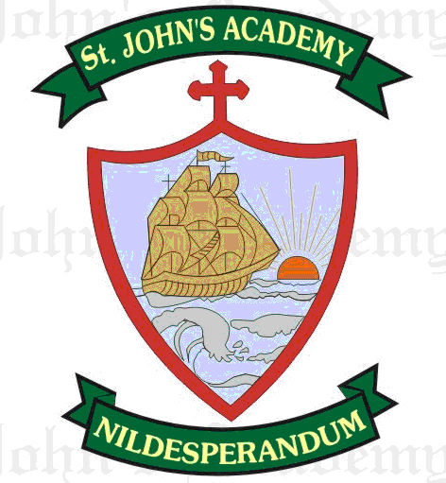
FINAL TERM SYLLABUS 2015-2016
CLASS – III

 | UNIT TEST | FINAL EXAM
ENGLISH LITERATURE & READING | The Ungrateful Goldsmith (10); The rabbit who thought she was somebody else (16) | Aladdin and the magic lamp (8); The lost pumpkins – I (18); The lost pumpkins – II (19)
ENGLISH LANGUAGE | Verbs (11, 12); The Articles (19); Essay – Diwali | Verb Tenses (13) ; Adverbs (20); Conjunctions (22); Essay – My Favourite Teacher; Formal Letter – Leave application; Comprehension.  From Prv. Terms : Pronouns; Prepositions; Nouns
SPELLING & DICTATION | Spell List 9 – 12; Seen Passage: The rabbit who thought she was somebody else | Spell List 13 – 16; Seen Passage: Aladdin and the magic lamp (8)
WRITING | Page No. 31 – 38 | Page No. 53 – 60
RECITATION | If I could be an astronaut (17); The silent snake (9) | Mothers are For (20); If I could be an astronaut (17)
MATHS | Fractions (13); Measures of Capacity (14); Mental Drill 30 – 36 | Time (9); Geometry (11); Mental Drill 37 – 46  From Prv. Terms : Division; Multiplication; Geometry (165 – 171); Fractions; Measures of Capacity
SCIENCE | Our Food (6); Safety Rules(9) | Materials (10); Weather (12); The earth and the sky (13)
SOCIAL STUDIES | Work (9); Festivals (12) | Go Green (16); Indian Cities (18); Going Places (13)
COMPUTER SCIENCE | Working with Paint (5) | The keyboard (6); MS Word 2007 (7)
GENERAL KNOWLEDGE | Page No. 27, 28, 29, 30, 31, 32, 33, 35; Current Affairs | Page No. 41, 42, 43, 45, 46, 52, 54, 55; Current Affairs
VALUE ED. | The Mother Bird and Her Young Ones (5); Thimmakka’s Children (6) | Well and Water (7); India a Secular Country (8)
HINDI LIT.; LANG. & DICTATION | le>nkj ckfydk (Š); y{; (ƒ†); fyax ; opu ;foykse; okD;ka”k ds fy, ,d “kCn; eqgkojs; f”k{kkizn dgkuh& canj vkSj exj  Dict. :Spell List 5 & 6; Seen Passage y{; (ƒ†) | ,d Hkwy ¼ˆ½] tgk¡ dk rgk¡ ¼„Œ½] fØ;k ¼„Œ½] fojke fpg~u] i;kZ;okph ¼ƒƒ½] vusdkFkZd ¼ƒƒ½] vifBr x|ka”k] fuca/k& o`{kksa ls ykHk] Spell list 7 & 8; Seen Passage ,d Hkwy ¼ˆ½
ART | Page No. 34, 35, 36, 39, 40, 41, 42, 45; In Drawing Copy - Saree Border in Rectangle; A peacock | Page No. 52, 26, 29, 60, 63, 64, 67, 68; In Drawing Copy – A Snow Man; A Circus Scene
SUPW | A Photo Frame ; Wall hanging (Paper Quilling) | Embossed Painting, Tissue Flower

