SAINT JOHN’S ACADEMY, ALLAHABAD
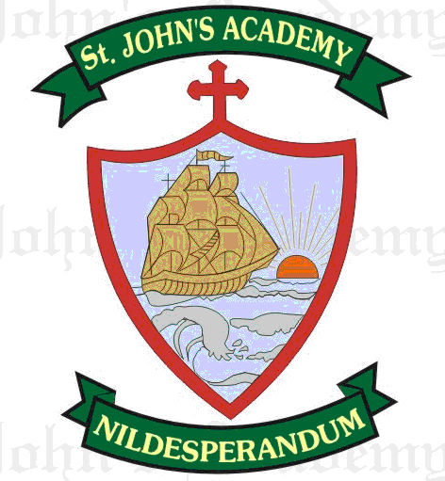
FINAL TERM SYLLABUS 2015-2016
CLASS – II

 | UNIT TEST | FINAL EXAM
ENGLISH LITERATURE & READING | Lift your head (8); Tom and Jerry (9) | The strange Friend (12); Cycling (16)
ENGLISH LANGUAGE | Adjectives (16, 17) ; Preposition (21, 22) ; Composition – My favourite toy; Comprehension | Conjunctions (23); Adverbs (19, 20); Yesterday & Tomorrow (11); Composition – My School; My Father; Comprehension
SPELLING | Spell List 9 – 12; Seen Passage: Lift your head | Spell List 13 – 16; Seen Passage: The strange Friend (12)
WRITING | Page No. 23 – 36 | Page No. 37 – 44
RECITATION | The cupboard | Cycling (16); Two Sides
MATHS | Money (8); Fraction (14); Geometry (13); Tables (1 – 15 x 10); Mental Maths Pg. 25 - 32 | Division (7); Measurement of Mass (11); Measurement of Capacity (12); Mental Maths Pg. 33 – 43 From Prv. Syllabus – Addition; Subtraction; Multiplication; Tables (1 – 15 x 10)
SCIENCE | Air (10); The Earth (11) | Day, Night & the Sun (12); The Homes of Animals (15); Eat Well Be Healthy (16)
SOCIAL STUDIES | Our Beautiful Earth (15); Water, water every where (16) | Seasons (17); The Story of the Wheel (19); The Mother (22)
COMPUTER SCIENCE | The Keyboard and its functions (5); Handling a Mouse (6) | Fun With Paint (7); Draw & Colour with Shapes (8); Tux Paint (9)
GENERAL KNOWLEDGE | Page No. 33, 34, 35, 36, 38 & 41; Current Affairs | Page No. 43, 45, 46, 47, 48, 49; Current Affairs
VALUE ED.  (Oral) | Consideration and concern for others; Honesty and Integrity | Hard Work; Good Action
HINDI LIT.; LANG. & DICTATION | c;k gekjh fpfM+;k jkuh ¼„Œ½] cky fnol ¼ƒ‰½] i;kZ;okph] foykse “kCn] la[;kokph “kCnA ys[k & nhikoyh] Spell list 5 & 6 | tk fQj ls pwgk gks tk ¼ƒ…½] Hkki dh “kfDr ¼„ƒ½] fØ;k] laKk] fyax] ys[k& esjk fo|ky;] f”k{kkizn dgkuh] Spell list 7 & 8
ART | Page No. 44, 45, 46, 49, 50; A Honey Bee; A colourful fish | Page No. 51. 52, 55, 56, 59, 60 ; An Aquarium; Poster Making (Save Trees)
SUPW | Ice Cream Utility box | Thermocol glass flower

