SAINT JOHN’S ACADEMY, ALLAHABAD
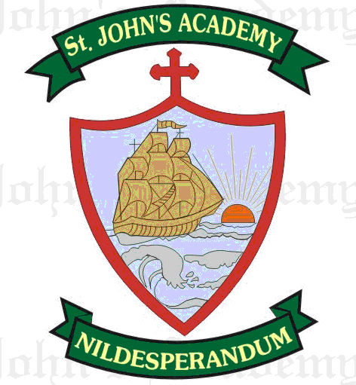
FINAL TERM SYLLABUS 2015-2016
CLASS – I

 | UNIT TEST | FINAL EXAM
ENGLISH LITERATURE & READING | A Child’s Thought (11) ; The Three Cats (13) | Who wins the Race (15); A witty answer (17)
ENGLISH LANGUAGE | Pronouns (10); Doing words(11); Am, is & are (12) ; Have & Has (13) ; Composition – 1 (My Self); Paragraph Writing – My Friend | Adjectives (15); Opposites (17); Pairs of words (18); In, on, under, Over (19); Was & Were (14); Paragraph Writing – My Teacher
SPELLING | Spell List 9 – 12; Seen Passage: A Child’s thought (11) | Spell List 13 – 16; Seen Passage: Who wins the Race (15)
WRITING | Page 23 – 28 | Page 29 – 34
RECITATION | The Three Cats (13) | Tadpoles(16); Miss Molly (19)
MATHS | Time (11); Shapes (13); Patterns (14); Collection of sets (16); Tables (1 – 8 x 10)  Mental Maths pg. 25 – 33 | Multiplication (9); Division (10); Measurement (15); Money (12); Data Handling (17) ; Tables (1 – 10 x 10); Mental Maths pg. 34 – 44; From Prv. Syllabus – Addition & Subtraction
SCIENCE | Cleanliness (9); Good Manners (10) | Air (12); Water (13); In the Sky (15)
SOCIAL STUDIES | This is my Class Room (11); Festivals are Fun (13) | Stay Healthy (15); Be Safe (16); We Love Bapu (20)
COMPUTER SCIENCE | Data and Memory (8); Storage in a Computer (9) | Using a mouse (6); Drawing with a Computer (7)
GENERAL KNOWLEDGE | Page 28, 29, 30, 32, 35, 38; Current Affairs | Page 43, 47, 48, 49, 52, 53; Current Affairs
VALUE ED.  (Oral) | Caring for others; Love nature | Respect for others; Love your country
HINDI | gekjk cxhpk ; oanuk ; laKk ]opu; ys[k &xk;; lIrkg ds fnuksa ds uke; Spell List 5 & 6 | >wB dk Qy] fyax] fØ;k] ys[k& gksyh] eghuksa ds uke] gksf”k;kj fdlku] Spell List – 7 & 8
ART | Page No. 34, 37, 40, 43, 44, 47; Our National Flag; A Train; Humpty Dumpty | Page No. 51, 52, 55, 56, 59, 60 ; A Scenery; A Butterfly in the garden
SUPW | Ice cream Spoon photoframe | Glass faces

