SAINT JOHNS ACADEMY, ALLAHAABAD
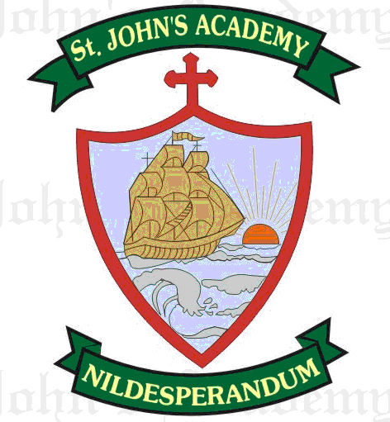
FIRST UNIT TEST SYLLABUS 2015-16
CLASS VIII

ENGLISH LANGUAGE → Elementary English Grammar & Composition - Class 8  CHAPTER TOPIC PAGE NO.  10 Active And Passive Voice 41- 44  35 Comprehension Passage 159 - 162  11 Adjectives 45 - 48  Degree of Comparison  Essay – Descriptive – a) An Ideal Student  b) My Study Room  Letter (Formal) - Write a letter to the editor of a local daily about the bad condition of roads and drains in your city requesting him to publish the same as to bring it to the notice of the appropriate authorities.  Comprehension Passage | ENGLISH LITERATURE →  CHAPTER TOPIC PAGE NO.  New Gems English Reader - Book 8  4 I Remember, I Remember! 22 (Poetry)  2 Einstein’s Compass 8 (Prose) Prose  Sixteen Tales from Shakespeare – Supplementary Reader  The Tempest 6 (Drama)
ENGLISH SPELLING & DICTATION →  Difficult words from the chapters taught in English Literature.  Seen Passage – Einstein’s Compass  Unseen Passage – Any chapter from the Literature book | ENGLISH ELOCUTION/ RECITATION → Poetry Magic Book 8 (Ref.)  The Old Familiar faces 13  I remember, I remember! 22
MATHEMATICS →  Foundation Mathematics – Book 8  CHAPTER TOPIC PAGE NO.  - Sets 1 – 13  - Venn Diagrams 14 – 20  16. Fundamental concepts and operations  On algebraic expressions 162 - 175  17. Formula 176 - 179  28. Lines and angles 269 – 284  3. Number 21 - 42  18. Exponents 180 - 188  30. Triangles 290 - 313  10. Unitary method 110 - 114  11. Time & Work 115 – 120  12. Time & Distance 121 – 129  13. Percentage 130 – 139 | HISTORY & CIVICS →  The Trail History & Civics - Class 8  CHAPTER TOPIC PAGE NO.  - Decline of the Mughal Empire 8  17. Over Population and Poverty 151  2. Rise of the Independent Regional Powers 14
GEOGRAPHY →  Geography Revised Edition – Class 8  CHAPTER TOPIC PAGE NO.  - Measurement of Temperature And Rainfall. 11  7. Celestial Bodies in The Solar System 58  1. Weather and Climate 1  3. Atmospheric Temperature 20 | PHYSICS →  New Oxford Science Physics – Book 8  CHAPTER TOPIC PAGE NO.  - Universe 7 - 21  - Light 22-41
CHEMISTRY →  Living Science Chemistry – Class 8  CHAPTER TOPIC PAGE NO.  2. Hydrogen 28  - Structure Of Atoms 3 | BIOLOGY →  Living Science Biology – 8  CHAPTER TOPIC PAGE NO.  Ch. 1 Transportation of Food & Minerals In Animals 3  Ch. 2 Transportation of Food & Minerals In Plants  18
COMPUTER SCIENCE →  A Text Book for Class IX  CHAPTER TOPIC PAGE NO.  - Introduction to Operating System 1-18  - Graphic User Interface 19-45 | GENERAL KNOWLEDGE →  G.K. Magic – 8  CHAPTER TOPIC PAGE NO.  - N for nature 4 to 9  - Words and more 10 to 14  - I Love my India 15 to 20
VALUE EDUCATION →  Good Karma – Part 8  CHAPTER TOPIC PAGE NO.  1. The Prayer that was answered 5  2. God’s Forecast 9 | ART →  Ship drawing and colouring with crayons
SUPW →  Table lamp design | P.T. →  March Past  Drills/Exercises
HINDI→ (LITERATURE) uwru ljy fgUnh ekyk& Hkkx Š  fo"k; ist uaŒ  tykrs pyks ¼dfork@in~;½ ƒ & †  Hkksyk jke dk tho ¼xn~;½ ‡ & ƒ…  dkdk dyke ls ckrphr ¼xn~;½ „‡ & …ƒ  HINDI (LANGUAGE) vuqie fgUnh O;kdj.k  fo"k; ist uaŒ  laKk&fyax] opu iqujko`fRr  fo”ks’k.k ds Hksn ¼laKk “kCnksa l sfo”ks’k.kksa dh ‰‡ &Šå  jpuk½ vad ls iqyd rdA  okD; ifjorZu& vFkZ ds vk/kkj ij ƒ…Š & ƒ…‹  eqgkojs ¼ƒ & ƒå½ ƒ†‡ & ƒ†ˆ  okD;ka”k ds fy, ,d “kCn ¼ƒ & ƒå½ ƒ„‡  rRle & rn~Hko ¼vJq ls mywd rd½ „…  Hkkookpd laKk& ¼tkfrokpd laKk ls Hkkookpd laKk½  i;kZ;okph& va/kdkj ls ryokj ƒƒˆ  vifBrx|ka”k  vkSipkfjdi=&vius “kgj ds fodkl izkf/kdj.k vf/kdkjh dks i= fy[kdj lM+d vkSj iqfy;k dh ejEer ds fy, izkFkZuk i=A  vukSipkfjdi=&viuh ekrk th dks viuh i<+kbZ ds ckjs esa tkudkjh nsrs gq,A  fuca/k ys[ku& ƒ- ns”k dh fofHkUu leL;kvksa ls lEcfU/kr ¼;krk;kr½A  „- ekuo thou esa uSfrd ewY;ksa dk egRoA | HINDI DICTATION  ƒ- dkdk dyke l sckrphrA  „- vifBr ikB lsA  SANSKRIT→ cky laLd`r df.kdk& 3  iwoZ jk’Vªifr% ,Œ ihŒ tsŒ vCnqy dyke% „‰&…Œ  “kCn :i& ^fir`* ‹‹  /kkrq :i ^lso* &yV~ydkj% ] y`V~ydkj ƒŒ„  o;afdadq;kZe\ ƒƒ&ƒ†
END

