SAINT JOHN’S ACADEMY, ALLAHABAD
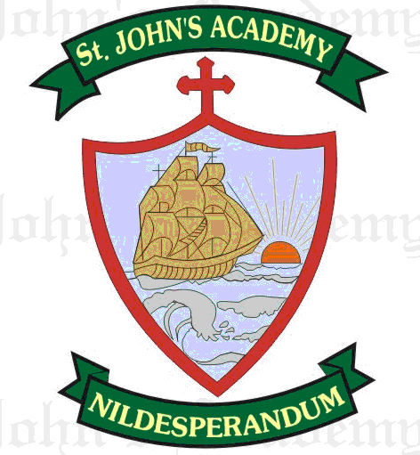
FIRST UNIT TEST SYLLABUS (2015-2016)
CLASS VI

ENGLISH LANGUAGE  Elementary English Grammar & Composition – Class 6  TOPICS PAGE NO.  - The Sentence 1 - 6  - Nouns: Kinds 7 - 11  10. Number 47 - 54  11. Gender 55 - 58  12. Case 59 - 61  4. Adjective 20 - 25  33. Letter(Informal)  (To father informing about the new Hostel)  14. Comparison Of Adjectives 66 - 69  15. Articles 70 - 73  23. Vocabulary 123 - 127  Essay- Imaginative (If I Were A Pencil…)  Comprehension 152  Picture Composition (Picture 2) 145 | ENGLISH LITERATURE  New Gem’s English Reader - 6  TOPICS PAGE NO.  2. The River Bank 8 - 13  4. The Jumbo Jet (Poem) 23 - 25  3. A Handful Of Salt 16 - 22
ENGLISH SPELLING & DICTATION  Difficult words from the chapters in English Literature.  Seen passage – 16. A Handful Of Salt  Unseen passage - Any chapter in the English Literature Book. | ENGLISH ELOCUTION/RECITATION  Poetry Magic Book – Book 6 (Ref.)  TOPICS PAGE NO.  What Was It? (Poem book) 13  4. The Jumbo Jet 23
MATHEMATICS  Foundation Mathematics - Class 6  TOPICS PAGE NO.  1. Number System 01 - 10  11. Sets 133 – 147  15. Fundamental Geometrical Concepts 175 - 181  2. Factors and Multiples 11 - 26  3. Integers 27 - 43  12. Fundamental Concepts of Algebra 148 - 158 | HISTORY & CIVICS  The Trail History & Civics – Class 6  TOPICS PAGE NO.  1. Sources of History 8 - 14  17. Introduction to Civics 123 - 127  2. Life In Pre Historic Times 15 - 22  3. Mesopotamian Civilization 24 – 30
GEOGRAPHY  Revised Geography - Class 6  TOPICS PAGE NO.  1. Globes and Maps 1 – 11  2. Essential features of Maps 12 – 18  3. Our Earth in the Solar System 16 - 28 | PHYSICS  New Oxford Science Physics - 6  TOPICS PAGE NO.  1. Introduction of Physics 1 - 2  2. Measurement 3 – 22
CHEMISTRY  Living Science - Chemistry - Book 6  TOPICS PAGE NO.  - Chemistry - An Introduction 3 – 9  - States Of Matter 10 – 23 | BIOLOGY  Living Science – Biology - Book 6  TOPICS PAGE NO.  8. Our environment 91 - 103  1. Life on earth 3 - 13
COMPUTER SCIENCE  Optima Cyber World - 6  TOPICS PAGE NO.  Chapter-1 – Computer Fundamentals 5 - 12  Chapter-2 - Tables in MS -Word 13 - 26 | GENERAL KNOWLEDGE  G.K. Magic – 6  TOPICS PAGE NO.  1. N for nature 4 to 8  2. Words and more 9 to 12  3. I Love my India 13 to 18  Quiz 1
VALUE EDUCATION  Good Karma - Book 6  TOPICS PAGE NO.  1. Obey your elders 5 - 8  2. National Integration 14 - 17 | Art  Shading with different pencils - Shapes
SUPW  Greeting Cards (Butterfly Cards) | P.T.  March past  P.T. Exercises/Drill
HINDI(LITERATURE)uwru ljy fganh ekyk & ˆ  ikB fo"k; ist uaŒ  ƒ viuk ns”k lWokjas ge ƒ & †  „ ?kj dh ryk”k ‡ & ƒŒ  HINDI (LANGUAGE)  vuqie fgUnh O;kdj.k rFkk jpuk Hkkx ˆ  fo"k; istuaŒ  laKk& fyax] opu …† & †ˆ  Hkkookpd laKk „‹ & ……  fØ;k& ldeZd o vdeZd ˆ„ & ˆˆ  okD; & ifjHkk’kk] vax ¼mn~ns”; o fo/ks;½ ŠŠ & ‹†  foykse ¼vLr ls e`r rd½ ƒŒ„ &ƒŒ…  eqgkojs ¼ƒ lsƒŒ rd½ ƒƒ† &ƒ„ƒ  i;kZ;okph ¼vfXu ls x.ks”k rd½ ƒŒƒ  i= ys[ku&ƒ- ubZ d{kk esa vkidk vuqHko dSlk jgk\ ;g crkrs gq, fe= dks i= fy[ksaA ƒ„†&ƒ…†  „- vLoLFk gksus ds dkj.k rhu fnuksa ds fy, iz/kkukpk;kZ dks vodk”k i=A  fuca/k ys[ku& ƒ- vkidks dkSu lk [ksy vPNk yxrk gS D;ksa\ ƒˆ„ &ƒ‰„  „- gekjk Hkkjr ns”k  vifBr xn~;ka”k | HINDI DICTATION  fo"k; ist uaŒ  „ ?kj dh ryk”k ‡ & ƒŒ  „ vifBr ikB ls  HINDI READING  fo"k; ist uaŒ  „ ?kj dh ryk”k ‡ & ƒŒ  ˆ gekjs iM+kslh „‹ & …‰  SANSKRITckylaLd`rdfudk& ƒ  TOPICS PAGE NO.  oUnuk ‹  izFke% ikB% & vge~ Roe~ ƒƒ& ƒ‡  f}rh;% ikB% & o;e~ ;w;e ƒˆ & ƒ‹  “kCn :i& cky  /kkrq :i&iB~ dk yV~ydkj ¼orZeku dky½

END

