SAINT JOHN’S ACADEMY,ALLAHABAD
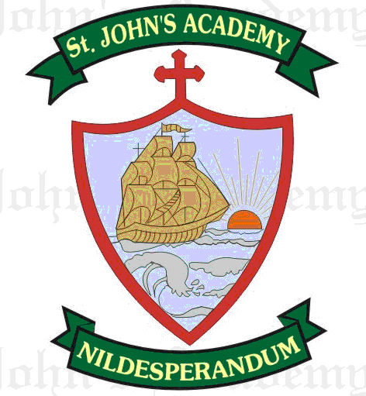
FIRST UNIT TEST SYLLABUS 2015-2016
CLASS XII
ENGLISH LANGUAGE → ISC English Language  A.T. Atkinson & Sumit Mitra  - Articles  - Agreement of verb with the subject  - Time and Tense  - The Sequence of Tenses  - Word Order  - Prepositions  - Words followed by prepositions  - Welcome speech  - A vote of thanks  - Book Review/ Film Review/ Reviews of a TV show/ Concert/ Theatre Review (Revision)  - Revision of Transformation of Sentences | ENGLISH LITERATURE →  ISC Collection of Short Stories (Inter University Press Pvt. Ltd.)  A Real Durwan  The Lost Jewels (Revision) from Class XI  ISC Collection of Poems (Frank Brothers & Comp.)  Five ways to kill a man  The Eve of Waterloo (Revision) from class XI  PLAY - Much Ado about nothing.  Act IV Scene 1
MATHEMATICS → ISC Mathematics For Class XII  Sec. A  Determinants and Matrices  Inverse Trigonometric Functions  Differential Calculus  Sec. B  Vectors  OR  Sec. C  Index numbers and moving average  Linear Programming | PHYSICS → ISC Nootan Physics Vol. II  Electrostatics  Current electricity  Magnetism (Not for Test)
CHEMISTRY → ISC Nootan Chemistry Volume II  Relative molecular mass and mole (A)  States of matter – solid state (A)  Alkyl and Arylhalide (C)  Chemical Kinetics (A)  Bio Molecules (C)  Preparation properties and uses of group 16, 17. | BIOLOGY → ISC Nootan Biology Volume II  Origin and evolution of life  - Origin of Life  - Theories of evolution – Lamarkism and Darwinism  Multicellularity  - Plants –  - Absorption and movement of water in plants.  - Photosynthesis
COMPUTER APPLICATIONS → Computer Science with Java – A Textbook for Class XII  Boolean Algebra  Computers Hardware  Implementation Of Algorithms to Solve Problems  Programming in Java  Objects  Inheritance and Polymorphism  Exception Handling  Primitive Values, Wrapper Classes, Variable Classes And Types and Casting.  Expression | ACCOUNTS→ ISC Accounts Class XII  Joint Venture  Partnership  Admission of partner  Retirement of partner/death of partner (Not for Test)
ECONOMICS → Frank ISC Economics Class XII  Micro and Macro Economics : Definition and 2 differences  Demand  Theory of Consumer’s Behaviour : DMU, IC Analysis  Elasticity of demand: Meaning: Types : Degrees: Methods; Numericals  Supply  Market Mechanism  Commercial & Central Bank  Money and its Functions | COMMERCE → ISC Commerce for Class XII  Marketing: Concepts and Functions  Marketing Mix  Consumer Protection  Business Environment  Financing  Specialised financial institutions
HINDI →
dkO; rjax
1- gYnh ?kkVhA
2- lqeu ds izfrA
iqujko`fÙk & lk[kh] fou; vkSj HkfDr] lPph fe=rk] nksgk ,dkn”kA
fueZyk
1- v/;k; & ƒˆ ] ƒ‰
2- v/;k; & ƒŠ
iqujko`fÙk & v/;k; ƒ & ‡
dFkk lqjfHk
1- HkkX; js[kkA
2- y{eh dk okgu
iqujko`fÙk & cw<+h dkdh] e/kqvk] j{kk ca/kuA
O;kdj.k
1- okD; “kq) djsaA
2- eqgkojs] okD; iz;ksxA

Note: Assignments / Projects / Practical’s in all the subjects to be done as per ISC 2016 syllabus.

END

