SAINT JOHN'S ACADEMY, ALLAHABAD
Class : Nursery Holiday Homework 2015-2016 Subject : Hindi

Name : ……………………………………………....… Roll No…….. Adm. No...................... Date:...................

  

  
 ¥
 
 
 
 
  

[P.T.O.]
[PAGE - 2]

  
  

r 
 
 




¥
[Contd......]
[PAGE - 3]
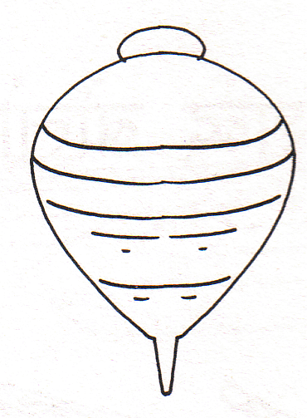



ƒ ˆ ƒƒ
ƒ„ ƒ‰
…
‹ ƒ†
„Œ


